Master Thesis
Title Section: The Most Recent Investigations on the Formatting of a Master Theses

submitted by [Author Name]
born on [Date of Birth] in [Place of Birth]

submitted for the academic degree of
Master of Science (M.Sc.)

Submission on [Date of Submission]

Supervisors [Title and name of the first supervisor]
[Institution]

[Title and name of the second supervisor]
[Institution]

Add the original task specification of the prime supervisor

Statement of Authorship

Herewith I declare that I am the sole author of the thesis named

„Title Section: The Most Recent Investigations on the Formatting of a Master Theses“

which has been submitted to the thesis assessment board today.
I have fully referenced the ideas and work of others, whether published or unpublished. Literal or analogous citations are clearly marked as such.

Dresden, [Date of Submission] Signature

Abstract
Please describe your work and your findings in a short text. Should be no longer than two pages.

Contents

Statement of Authorship 5
Contents 1
Figures 2
Tables 3
Formulas 4
1 Main Chapter 5
1.1 First Subchapter Level 5
1.1.1 Second Subchapter Level 6
1.1.2 Second Subchapter Level 6
1.1.2.1 Third Subchapter Level 6
2 Main Chapter 6
References 8

Figures

Fig. 3.1 Detail of Section 60 of the Elbe Map by W.G. Lohrmann. 7

Tables

Tab. 3.1 Example of a table 7

Formulas

Formula 1 7

- Main Chapter
  - First Subchapter Level
    - Second Subchapter Level
    - Second Subchapter Level
      - Third Subchapter Level
- Main Chapter
Research at the Institute has been fully integrated into the profiles of the faculty of environmental sciences. It is dedicated to cartographic theory, methods and modelling.
The Cartography master course is a unique offer within the spectrum of German academic education. A master degree in Cartography is only conferred by the three participating universities at Munich, Vienna and Dresden, which provide all topics and supervision of the master theses. Such solitary standing assigns specific prominence to the programme for its unmatched role as a source of academic offspring in the field of Cartography (Mustermann, 2011).

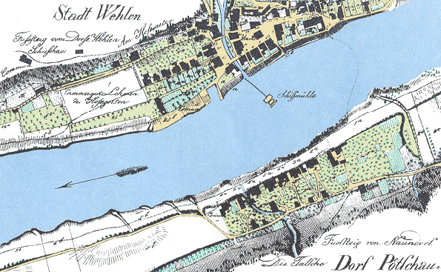
Figure 1. Detail of Section 60 of the Elbe Map by W.G. Lohrmann.

 | Jan | Feb
Temperature in °C | 3 | 5
Percipitation in mm | 100 | 80
Tab. 0.1 Example of a table

${\left(x+a\right)}^{n}=\sum_{k=0}^{n}{\left({n \atop k}\right)x^{k}a^{n-k}}$
Formula 1

References
Mustermann, M. (2011): Book or Paper Title. Name of Book or Journal , where it hasd been published, Volume and Issue if it is a Journal, Publisher (Book), Town, pp. 50-60

