Communicative Approaches in University Vocational Teaching Methodology focusing on Improving Educational Yield and Sustainability.

Content

About CBHE………………………………………………………………………………………..3
Aims and Objectives 4
Partner Universities 5

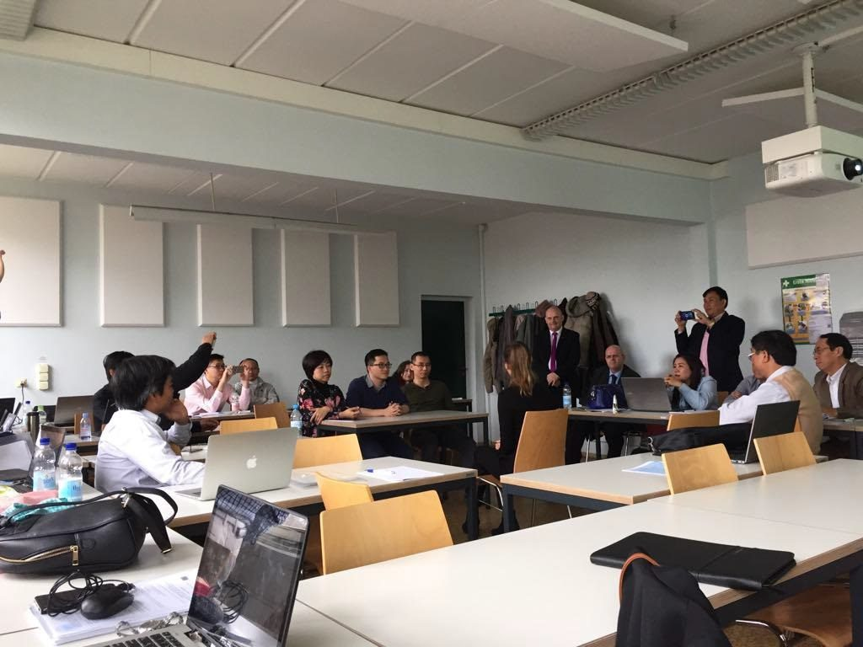

CATALYST LSP 2 Training
11-23 March 2018
Technical University of Dresden

The CATALYST Project

For detailed information see the CATALYST website:
https://catalyst-erasmus.com/

About CBHE

The CATALYST project has been funded by the European Commission through the Capacity-Building in Higher Education Programme (CBHE) as part of the Key Action 2 projects. CBHE is the European Union’s programme whose aim is to improve, develop, and modernise higher education systems and to support cooperation of Partner Countries across different regions of the world such as Eastern Europe and (Central) Asia mainly through university cooperation projects.

Aims and objectives of the CATALYST Project:

The specific objective of CATALYST is the development and implementation of a comprehensive pedagogical Core Curricula using an ECTS/Tuning Modular design for university vocational teaching for Vietnam and Laos.

Wider objectives are to:
- develop transparent, national and international educational standards and comparable learning tools and teaching standards in accordance with Bologna criteria.
- enhance the quality of teaching methodology and the use of innovative teaching tools in the Programme Countries
- support the internationalisation of participating EU and PC institutions and support staff and student mobilities and exchanges.
- improve the quality and participation of graduates in the educational system and in employment.

Specific objectives are to:
- implement English for Specific Purposes training as a Quality Assurance (QA) mechanism to ensure effective Programme Country participation and to use this package for future training needs at Partner Country institutions.
- implement Pedagogical training for Programme Country participants to ensure the Programme Countries produce a proper Core Curricula developed to local needs curricula.
- conduct Quality Assurance training for all participants at the Start Off meeting to ensure full implementation of project goals and to ensure understanding of the Quality Plan and the Contingency Plan.
- ensure the setting up of the Online Platform after needs analysis in Month 2 of project for uploading all academic and administrative documentation.
- create clear understanding of management structures for smooth operation of academic and administrative activities.
- develop a programme with clear focus on persons with disabilities.
- ensure Sustainability through Official Accreditation Process for Core Curricula including Inter-University Module Recognition Agreements and Action Group for the creation of a Strategic Plan for post-project dissemination and sustainability
- develop and implement a clear strategy to maximize Dissemination effects of two National Programme Country Project Status Conference Awareness Days.

Partner Universities

University Politehnica of Bucharest (UPB)
University Politehnica of Bucharest (UPB) University POLITEHNICA of Bucharest (UPB) is the largest and oldest technical university in the country and among the most prestigious universities in Romania. POLITEHNICA of Bucharest (UPB).
The University POLITEHNICA of Bucharest has participated in many European programs, e.g. FP5, FP6, and FP7 ICT and energy projects (H2020 R&D programme Marie Sklodowska-Curie, H2020 DATA4WATER – Excellence in Smart Data and Services for Supporting Water Management, H2020 COSNED – Radio wave propagation in heterogeneous media: implications on the electronics of Cosmic Neutrino Detectors, and Erasmus+ KA2 REDESIGN).

Technische Universität Dresden (TUD)

Technische Universität Dresden (TUD) The Technische Universitat Dresden, Germany, is one of the largest technical universities in Germany and is a full university with 14 faculties including medicine, pedagogy etc (over 42000 students including 3200 international and 4700 staff)

Paul Francis East representing The Pyramid Group (TPG)
Paul Francis East representing The Pyramid Group (TPG) PFE offers a large range of quality specialist industry, public sector and academic training (EAP/ESP) covering areas such as libraries, legal (national and international), public administration, special needs /disability awareness training in Ireland via the Irish Wheelchair Association and for primary school teachers.

Edge Hill University (EHU)
Edge Hill University (EHU) Edge Hill University (EHU) has been at the forefront of initial teacher training for 130 years and is a leading institution for teacher training in the north-west of England. With a network of nearly 4,000 schools, colleges and other learning environments, EHU provides initial teacher training.

Limerick Institute of Technology (LIT)
Limerick Institute of Technology (LIT) LIT provides three cycle system education, training and research, playing a pivotal role in the economic and sociocultural development of the region with a distinctive educational philosophy of active learning throughout its programs, in all disciplines and at all levels.

Ho Chi Minh University of Technical Education (HCMUTE)
Ho Chi Minh University of Technical Education (HCMUTE) Founded in 1962, HCMUTE was the first university in Vietnam educating and training vocational technical teachers for the whole country and is the leading university in this area. During its 55 years of development, HCMUTE has been reorganized several times and has gained many awards.

Ho Chi Minh University of Technology (HUTECH)
Ho Chi Minh University of Technology (HUTECH) HUTECH possesses highly ranked and nationally-recognized academic programs such as Business Administration, Finance and Accounting, Electrical and Mechanical Engineering, Architecture and Arts, Hospitality and Tourism, Bio-Food Technology, Law, and Social Sciences and Humanities.

Hanoi University of Science and Technology (HUST)
Hanoi University of Science and Technology (HUST) Established in 1956, HUST is now one of the leading universities in Vietnam, with the aim of becoming a world-class multi-disciplinary institution in doing research and providing high-quality human resources, not only in the field of natural sciences and technology but also in social sciences and humanity.

University of Languages and International Studies – Vietnam National University (ULIS – VNU)
University of Languages and International Studies – Vietnam National University (ULIS – VNU) University of Languages and International Studies in Hanoi, Vietnam, is one of the seven universities that comprise Vietnam National University in Hanoi - a leading university in Vietnam. The University of Languages and International Studies (ULIS) is a prestigious research university.

Hung Yen University of Technology and Education (UTEHY)
Hung Yen University of Technology and Education (UTEHY) Hung Yen University of Technology and Education is a public university managed by the Ministry of Education and Training with the strength of professional education, then upgraded to the major interdisciplinary university of science and technology in the Red River Delta, Vietnam.

Vinh University of Technology Education (VUTED)
Vinh University of Technology Education (VUTED) Vinh University of Technology Education (VUTED) locates in Vinh city, Nghe An province, Vietnam, founded in 1960 as Vinh Mechanical worker training school. In 2006, after changing the name three times, Vinh University of Technology Education was established.

National University of Laos (NUoL)
National University of Laos (NUoL) The National University of Laos is the leading vocational teacher training university in Laos. Founded in 1996 and located in the Laotian capital Vientiane, it is the only national university in the country. Currently NUoL has about 30,000 students, 1,931 academic and 411 administrative staff.

University of Health Sciences (UHS)
University of Health Sciences (UHS) The University of Health Sciences of Lao PDR (UHS-Laos) is the unique university for health professional training in the country, established in June 2007. This young university is composed of seven faculties such as Faculty of Basic Sciences, Faculty of Medicine, Faculty of Pharmacy, Faculty of Dentistry, Faculty of Nursing.

