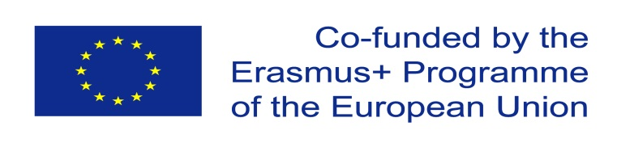

Developing Trans-regional information literacy for lifelong learning and the knowledge economy [DIREKT].

Content

About CBHE………………………………………………………………………………………..2
Reasons for the DIREKT Project……………………………………………………………….2
Aims and Objectives 3
Partner Universities 6
Overview of Project Activities, Training & Modules 26
Timeline 29
Project Management 32
Cooperation and Communication 33

About CBHE

The DIREKT project has been funded by the European Commission through the Capacity-Building in Higher Education Programme (CBHE) as part of the Key Action 2 projects. CBHE is the European Union’s programme whose aim is to improve, develop, and modernise higher education systems and to support cooperation of Partner Countries across different regions of the world such as Eastern Europe and (Central) Asia mainly through university cooperation projects.

Reason for the DIREKT Project:

The DIREKT project aims to instill best Information Literacy (IL) practices in higher education systems in the Russian Federation, Kazakhstan & China. The project is much needed in order to up-skill library and academic staff specifically their transferable, pedagogical and lifelong learning skills in the Information Literacy field thereby developing capacity and affecting all stakeholders including students. The project aims for improved, more relevant university services in the Information Literacy area leading to better awareness, modernization and improvements in teaching and learning.

Concise Description: Creation with Librarians and Faculty, of curriculum-integrated IL programs (embedded in the three cycle system (bachelor/master/doctorate), quality assurance and recognition of qualifications for the development of lifelong learning in higher education and in Society at large and incorporating appropriate electronic media. Development of training programmes supported by 7 ECTS modules- a DIREKT Curriculum for Information Literacy which will be embedded in curricula in PC universities and with involvement of external stakeholders to ensure maximum transfer effect to Society at large.

Impact envisaged: As Information Literacy is a vital transferable skill for lifelong learning that transcends all academic disciplines what is truly special and unique about this project is that the results will benefit a huge learner group- all University staff, students and librarians and the effects will be felt in RF, KZ and Chinese Society through university links with external stakeholders.

Aims and Objectives

The wider objectives of the project are:
- to further the Bologna Process for a Europe of Knowledge by developing Information Literacy (IL) programs for use in curricula in HE and society at large.
- to create, with librarians and faculty, curriculum-integrated IL programs (embedded in the three cycle system bachelor/master/doctorate).
- to support quality assurance and recognition of qualifications for the development of lifelong learning in higher education and in society at large.
These innovative programmes and technologies will benefit all stakeholders such as undergrad and postgrad students, librarians, academic staff, ministries, national and public libraries, local communities, non-academic members and society organisations.
Libraries and information literacy (IL) are a precondition for lifelong learning, Knowledge Economy, labour markets and a key to fulfilling the Lisbon strategy of making the EU the most competitive economy in the world.
The specific objectives are:
- to develop IL programs for lifelong learning as part of the DIREKT Curriculum for Information Literacy
- to develop innovative IL online modules for lifelong learning.
- to ensure the harmonisation of the IL programs with those currently active in the RF, KZ, CN
- to strengthen the capacities of Higher Education Institutions for the strategic planning and implementation of IL programs to instill transferable skills for a competitive, dynamic, knowledge-based economy.
- to develop an IL policy, guidelines, goals, mission.
- to disseminate the approaches to IL development and to ensure their exploitation and sustainability.
- to develop IL in society through strong involvement of non-academic partners, Associate Partners and society organisations.
While the DIREKT project and Curriculum is primarily concerned with developing IL and library skills, the programmes will also feature one module "Information Literacy & Academic Writing" (module 7) because, as is agreed internationally by experts, both disciplines are inseparable. As explained well by Kimmins and Stagg (2009) "effective writing and presentation skills are diminished if used to share flawed or incomplete information, hence before good academic writing is dependent on the learner achieving a good level of Information Literacy".
DIREKT will address critical problems and gaps that exist in University services provision leading to modern, relevant & accessible library and information services for all learners. Problems are such as the need to develop IL skills for successful integration into the international academic community (MHRU 2014) and the complete lack of quality academic writing regulations and standards (KSU 2014), poor awareness of Information Literacy and plagiarism issues (BIT 2016). The DIREKT Curriculum will lead to a change in this situation because in breath, scale, quality and relevance it will be the first programme of its kind held in these countries to address the Information Literacy training needs of librarians and academic staff with transfer to students and all other stakeholders.

Partner Universities

P1. Limerick Institute of Technology (LIT)
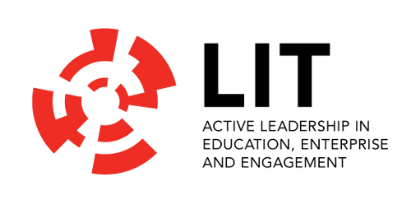
LIT provides three cycle system education, training and research, playing a pivotal role in the economic and sociocultural development of the region with a distinctive educational philosophy of active learning throughout its programs, in all disciplines and at all levels ensuring that it stays firmly in touch with the needs of industry and the community in the regions it serves. LIT has an international reputation for developing and implementing innovative Library projects, products and services through its Library and Information Resources Centre and has led Tempus projects in the Library and Information Science field dealing with Staff Development, Information Literacy and general Library Reform. In 2014 LIT were recognized by the European Projects Association for Distinguished Effort in the Development of the European Union through European Projects, improving library services and for efforts in building a better society for the EU TEMPUS project Developing Information Literacy for lifelong learning and knowledge economy in Western Balkan countries. LIT are also partners in the Tempus project 530345 Access to Society for People with Individual Requirements (ASPIRE) which aims to foster the rights of individuals with special needs in Armenia and Georgia to access education and they led the design and development of the “Use the Library” module for the ASPIRE Curriculum. LIT have also led important national library and information literacy projects such as the Library Network Support Services (LNSS) project from 2008-2011 which dealt with the Implementation of vital library and information literacy initiatives across multiple universities in Ireland.
Project link: http://mislibsrv.lit.ie/
Contact: Jerald Cavanagh BSc Econ, MSc, MA
ERASMUS + CBHE Project Leader
Institute Librarian
Limerick Institute of Technology
Moylish Park, Limerick, V94 EC5T, Irland
Phone: +353-86-8366726
Mobile: +353-61-293806
Fax: +353-61-293301
Email: Jerald.Cavanagh@lit.ie
Skype: jerald.cavanagh

Padraig Kirby BA (Hons) HdipLIS, MSc (LIS)
ERASMUS + CBHE Project Coordinator
Senior Library Assistant
Limerick Institute of Technology
Moylish Park, Limerick, V94 EC5T, Irland
Phone +353-61-293516
Mobile: +353-87-9734896
Fax: +353-61-293301
Email: Padraig.Kirby@lit.ie
Skype: padraigkirby

P2. Technische Universität Dresden (TUD)
The Technische Universitat Dresden, Germany, is one of the largest technical universities in Germany and is a full university with 14 faculties including medicine, pedagogy etc. (over 42000 students including 3200 international and 4700 staff). As a former part of the Soviet bloc of East Germany TUD has significant experience working with universities from the central European and former USSR regions.
It is in the small group of 11 German elite universities and has extensive EU project experience having been involved in over 50 Tempus projects.
The Centre of Applied Language and Culture is one of the largest structures at the university and has a Media Centre and a Bologna Process Implementation Unit, having introduced its own ECTS module system based on a communicative teaching approach and has assisted other universities in this. Most importantly the Centre has developed comprehensive EMI training, in addition to Academic, Scientific and Professional writing modules for both German and International students with added training for professors and key administrative management staff. With the advent of the Bologna Process, the LSK was the first structure at TU Dresden to introduce BP reforms and train all other faculties in ECTS TUNING curricula development including sciences, humanities etc..
The combined Saxon State Library and TU Dresden University Library (Sächsische Landesbibliothek – Staats- und Universitätsbibliothek Dresden or SLUB - http://www.slub-dresden.de) is one of the largest libraries in Germany for scientific and research purposes and one of the most innovative and a key player in German and European library development. The Centre of Applied Languages and Culture (LSK), in co-operation with SLUB, is responsible for the English language scientific research and writing modules for those students planning in doing their bachelor, master or PhD thesis as well as a wide range of academic papers.
Project link: http://www.slub-dresden.de/en/home/
Contact: Gerard Cullen
Project Manager
Technische Universität Dresden (TU Dresden)
Mommsenstrasse 13, 01062 Dresden, Germany
Phone: +49-351-46331684
Mobile: +49-152-52756778
Fax: +49-351-46331698
Email: Gerard.Cullen@tu-dresden.de
Skype: cullen9

P3. Constantine the Philosopher University (UKF)
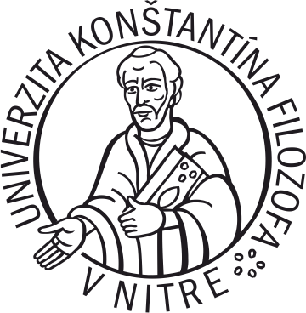
Univerzita Konštantína Filozofa v Nitre, Slovakia (UKF v Nitre) offers a variety of study programmes at bachelor, master and doctoral level. In addition to its strong tradition in training of teachers for primary and secondary schools, UKF also offers study programmes for future social workers, experts for cultural organizations and institutions, political scientists, catechists, journalists, archaeologists, historians, musicologists, biologists, environmentalists, mathematicians, physicists, computer scientists, psychologists, gemmologists and other professionals.
Univerzita Konštantína Filozofa v Nitre (UKF v Nitre) includes the Faculty of Education, Faculty of Natural Sciences, Faculty of Arts, Faculty of Social Sciences and Health Care, and the Faculty of Central European Studies.
The University Library is a scientific, information, bibliographic, coordinating, and advisory center to support the teaching and research processes at the University. The library and information services are provided to teachers and scientists, doctoral students, students of all forms of study and other professionals. The University Library provides inter-library loan services, international inter-library loans, advisory and reference services, and bibliographic and research services. The University Library collection consists of approximately 228 709 books and the Library has approximately 15 087 readers. Publications (books, study materials, journals etc.) can be searched via the University Information System. The University has licensed access to external sources of information: Scopus, Knovel, ProQuest, EBSCO Publishing, licensed databases (NISPEZ) and other databases freely accessible on the Internet such as the online catalogue of the University Library, the Slovak National Bibliography, the Czech National Bibliography as well as the database of publishing activities of the University staff.
Project link: https://www.pf.ukf.sk/index.php/sk/veda-a-vyskum-2/projekty/24-veda-a-vyskum/veda-a-vyskum-2/254-direkt
Contact: Dr. Eva Reid
doc. PhDr. Božena Horváthová, PhD.
doc. PhDr. Katerina Gajdáčová Veselá, PhD.
Univerzita Konštantína Filozofa v Nitre (UKF v Nitre)
Tr. A. Hlinku 1, 949 74, Nitra, Slovakia
Phone: +421-37-6408-231 or +421-37-6408-232
Mobile: +421-918-349-973
Fax: ---
Email: ereid@ukf.sk
Skype: ---

P.4 Paul Francis East representing The Pyramid Group (TPG)
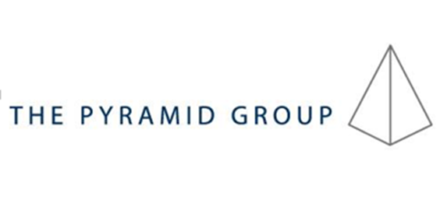
PFE representing Pyramid Group offers a large range of quality specialist industry, public sector and academic training (EAP/ESP) covering areas such as libraries, legal (national and international), public administration, special needs/disability awareness training in Ireland via the Irish Wheelchair Association and for primary school teachers as well as in the EU and PC’s. It has provided additionally specialised technical training in English for German companies in the engineering and manufacturing sectors (including leading companies such as Daimler, EADS, Voith, PERI, Iveco Magirus, Bosch Siemens and Dachser). Finally it provides translations and interpreting for German public service employees.
It particularly specialises in providing Bologna Process ECTS module training and EU Common European Framework differentiated English language training in communication skills and in terminology acquisition in these fields using both traditional and also ICT approaches. TPG are also a provider of project websites and of Blended Learning training and a provider of various quality training courses in the Management field covering topics such as Marketing, Strategic Planning, Customer Care, Time Management, Communication and Listening Skills, Presentation Skills, Decision Making, Problem Solving, Leadership Skills as well as Management of Change. TPG also provide expert advice in the areas of quality assurance, ECTS and Bologna compliance as well as editing and publication processes and have experience of these activities from previous Tempus projects.
The Pyramid Group has a long and fruitful relationship with TU Dresden and Ulm providing hands-on tailor made courses and training modules. The advantage of The Pyramid Group is its strong connections with publishers and its ability to acquire experts to undertake short or long term training. PFE representing The Pyramid Group have been involved in five Tempus projects and were also partners in the Tempus project 530345 Access to Society for People with Individual Requirements (ASPIRE) which aims to foster the rights of individuals with special needs in Armenia and Georgia to access education and they led the design and development of the English for Special Needs oral and writing skills programme and the marketing focused National Awareness Campaigns. Additionally it provided dissemination expertise as partner in the Capacity Building in Higher Education (CBHE) project 561987 Library Network Support Services: modernising libraries in Western Balkan countries through staff development and reforming library services [LNSS] as well as other CBHE project about library modernisation in Armenia, Moldova and Belarus.
The Pyramid Group has the advantage of close links to industry and has a cutting edge advantage in that it can hire specialists which other universities may not do so quickly and can offer professional support in self-financing approaches and in dissemination and sustainability strategies.
Project link: http://thepyramidgroup.biz/pyramid-international/
Contact: Paul East
CEO The Pyramid Group
Schweinmarkt 6, 89073 Ulm, Germany
Phone: +49-731-3976976
Mobile: +49-170-1842435
Website: http://thepyramidgroup.biz/
Email: paul@thepyramidgroup.biz
Skype: pyramidpaul

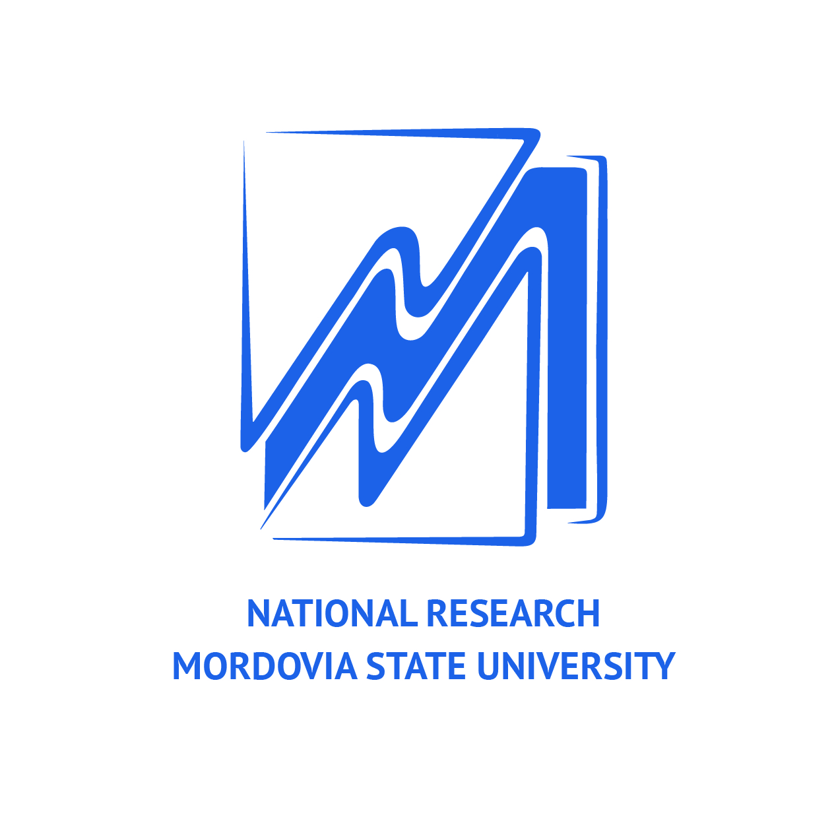
P5. Ogarev Mordovia State University (MRSU)
MRSU, founded in 1957, is one of the top hundred and largest universities in Russia. There are 109 undergraduate and 93 postgraduate educational programs and 27 Academic Boards that issue PhD (Candidate) degrees. The total number of students is 24000 (including around 210 international students).
The university actively develops cooperation with universities in Europe, Africa, Asia, Middle East, Finno-Ugric Countries and the USA. Each year over 200 people (staff members, students, lecturers) go abroad to improve the integration of the Russian educational system into the European educational space, to establish agreements with other foreign universities, to participate in international programs of academic mobility. The university also runs various international projects such as INTAS, TEMPUS-TACIS, and Lifelong: JEAN MONNET. In 2010 MRSU acquired the status of the National Research University along with 28 institutions of higher education in Russia.
MRSU developed the Information programme for 2012-2019. Its guidance document is the State Program of the RF "Information Society 2011-2020". This programme for Information development of the University is signed and approved by the Ministry of Education and Science of RF on 09.07.2010. It states the complex development of the University in the field of IT and Information literacy.
The university arranges the classes for information skills competence which are part of the curricula and that are conducted by the University Library. The materials of this course can be used for the formation of information competence for under-graduate and post-graduate students and teaching personnel of the University. It provides the knowledge, skills and tools to work with the information acquired in the framework of any academic major and during the entire study period.
Project link: http://www.mrsu.ru/ru/international/collab.php?ID=61170
Contact: Dr. Natalia Burenina
Ogarev Mordovia State University
68 Bolshevistskaya Str., Saransk 430005, Republic of Mordovia, Russia
Phone: +7-8342-48-24-32
Mobile: +7-906-379-10-80
Fax: +7-8342-48-24-32
Email: bureninanv@mail.ru
Skype: bureninanv57

P.6 Far Eastern Federal University (FEFU)
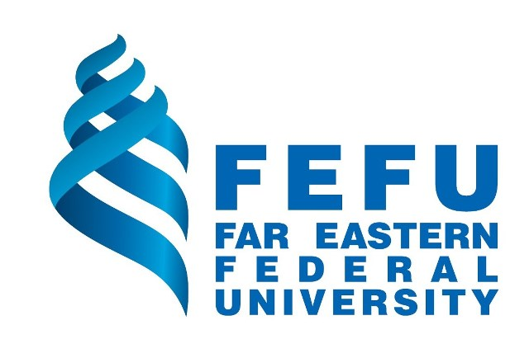
Far Eastern Federal University (FEFU) counts more than 42.000 students enrolled in more than 300 educational programs, including 84 bachelor degree programs and 54 graduate programs. It comprises 9 schools: School of Engineering, School of Natural Sciences, School of Biomedicine, School of Regional and International Studies, School of Business and Public Administration, School of Law, School of Humanities, School of Education, School of Arts, Culture and Sports. In 2010, the FEFU acquired the status of a Federal University. It strongly supports professional development in teacher training through participation in international projects and hosts conferences in different areas. FEFU faculty members have participated in the following EU projects: Development of Qualification Framework for Food Science Studies at Russian Universities (DEFRUS № 517336-TEMPUS-PL-TEMPUS-SMHES), Strengthening the Lifelong Learning in Environmental Sciences in Russia (530397-TEMPUS-1-2012-1-SK-TEMPUS-SHMES), Promoting Sustainable Excellence in Education (517114-TEMPUS-1-2011-1-UK-TEMPUS-SMHES).
FEFU Research Library’s history dates back to 1899. Today FEFU Research Library holds over 2 million volumes in Russian, German, English, French, Korean, Japanese, Arabic, Czech, Spanish and many other languages dating from the 16th – 21st centuries. The library has the methodological department which can participate in designing training materials. FEFU Research Library is presented as Regional Methodological Center for University Libraries of the Russian Far East (decree # 1247 of April 27, 2000 of Ministry of Education of the Russian Federation). It is also a member of the Russian Library Association and the “National Electronic-Informational Consortium” NGO.
Project link: https://www.dvfu.ru/schools/school_of_regional_and_international_studies/news/teachers_of_the_department_of_linguistics_and_intercultural_communication_started_in_the_framework_of_the_international_project_of_the_foundation_erasmus_/
Contact: Yulia Polshina,
Associate Professor
Far Eastern Federal University (FEFU]
8 Sukhanova St., Vladivostok, 690091, Russia
Phone: +7-423-240-22-43
Mobile: +7-914-731-5641
Fax: ---
Email: ypolshina@yandex.ru
Skype: julia.polshina

P7. Immanuel Kant Baltic Federal University (IKBFU)
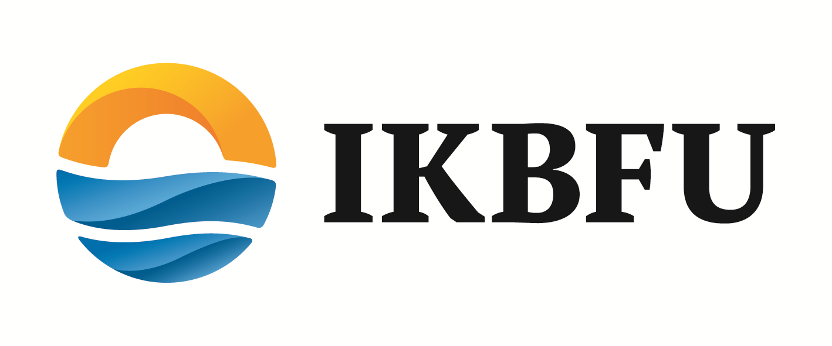
IKBFU is the educational, research, and cultural center of the RF exclave. Being a federal University IKBFU is aimed at internationalization and adaptation of the best practices of leading world universities. IKBFU participates (or has participated recently) in the following international programs and projects: Erasmus Mundus Triple III External Cooperation Window; Erasmus Mundus Aurora — Towards Modern and Innovative Higher Education; Tempus Programme – Promoting Sustainable Excellence in Testing and Assessment of English (PROSET); Tempus programme - Extended three-level competence-based educational programme in the field of Applied Marine Sciences; ENPI Russia Action Program 2009 of the EU "EU4U: Establishment of the EU Centre at the University; IKBFU participates in several international projects including “Russia and Europe: Past, Present, and Future”.
The IKBFU library was opened in 1948 and serves more than 16000 readers. It includes more than 640 000 books and other print materials. It also has subscriptions to many electronic data bases and library sources, including IEEE Xplore, Grebennikon, MathSciNet, WILEY, Nature Publishing Group, etc. The Library regularly holds seminars aimed at enabling students to use e-sources (in Russian and English). Moreover, it serves as a platform for students’ projects (like BiblioNight, AstroNight, StART Night, etc.) and boasts 21 valuable items of the famous Wallenrod Library collection.
The Library is active on the international level having cooperation links with libraries in Germany, GB, Sweden, Denmark, France, Poland and Lithuania.
Project link: https://www.kantiana.ru/international/partnerorganisations/project/
Contact: Dr. Natalya Milyavskaya
Head of the Division for International Programmes
Immanuel Kant Baltic Federal University (IKBFU)
14. A. Nevskogo St., 236016 Kaliningrad, Russia
Phone: +7-4012-313399
Mobile: +7-9052460055
Fax: ---
Email: nmilyavskaya@kantiana.ru
Skype: Milyavskaya.Natalya

P8. Petrozavodsk State University (PetrSU)
PetrSU is one of the largest universities in the North-European part of Russia. It successfully combines traditions of classical education and fundamental science with innovative solutions in the fields of physical education, sport and health care. It is regularly placed among the best universities of Russia according to different rankings. Today more than 12000 students attend classes in various undergraduate, graduate and post-graduate programs. They are taught by over a thousand professors, including 550 PhDs, 145 Doctors of Science, 26 members of state academies of science. PetrSU is also a recognized leader in development of IT and international cooperation among universities of Russia. It has all necessary legal, accounting, international relations, technical support, teaching and research units. PetrSU has enough teaching auditoriums, meeting rooms, conference halls, computer labs, networking equipment, etc. The technical infrastructure, size and qualification of staff are enough to manage the project with required quality and in agreed time schedule.
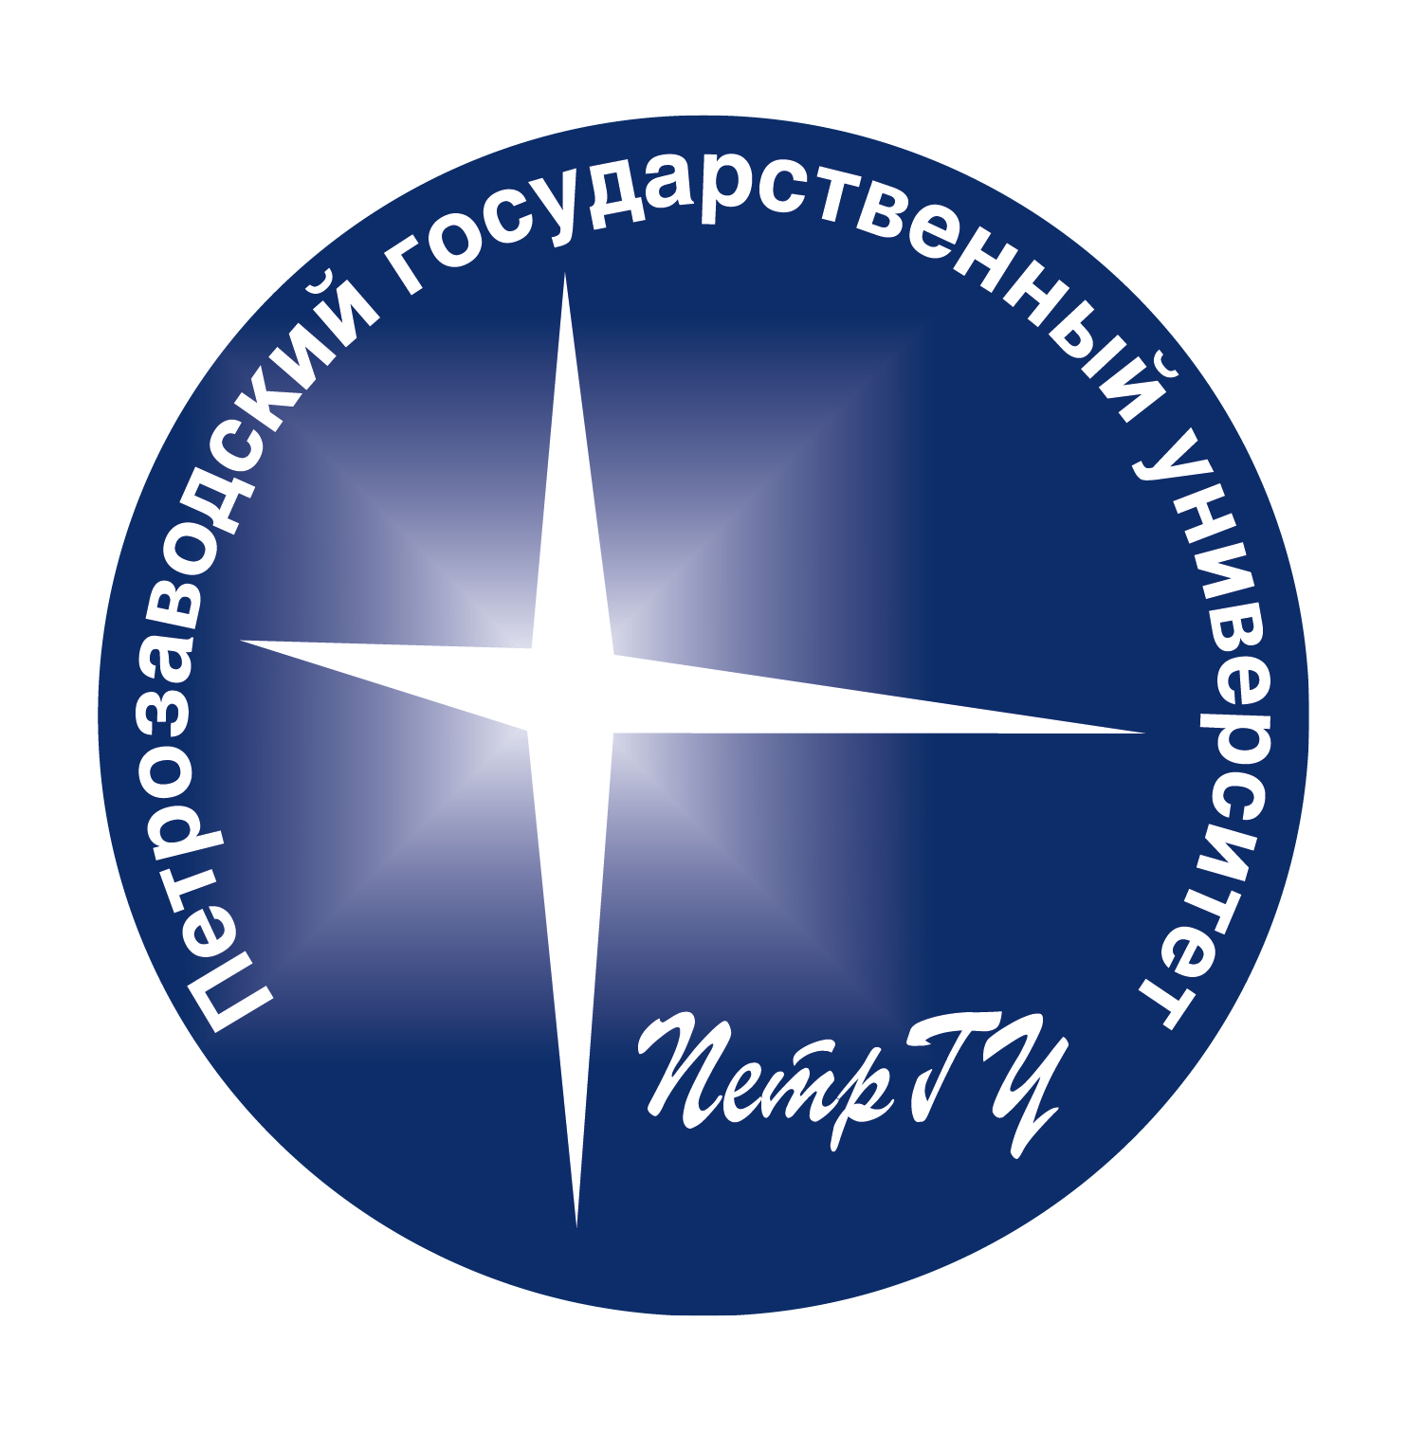
The collection of the Scientific Library contains books in various field of knowledge including fiction, and foreign literature in 18 languages: English, German, French, Finnish and others, unique printed books, and rare books from XVI - XIX century.
The library's collection grows approximately by 40000 entries per year. Since 1992, the Scientific Library of PetrSU has been introducing new information technologies into its work. The work on creating electronic catalogue began with the establishment of the new automation informative Library System (AILS) "MARC" (Scientific Industrial Union "Informsystem"). Since 1996, the Library has been taking part in adopting the new electronic system "Foliant", worked out by the engineers of RCNIT Gurijev D. and Matsko S. This version provides faster and more convenient search in the catalogues. Today, 3181582 entries are forwarded to "Foliant". Some of the Resolutions of the Russian Federation and the Republic Karelia are left in 'MARC'.
Project link: https://petrsu.ru/structure/5942/pages/2923/capacity-building-in-higher-educati
Contact: Marina Gvozdeva
Vice-Rector for International Affairs
Petrozavodsk State University (PetrSU)
Lenin av, 33, Petrozavodsk, Russia, 185910
Phone: +7-8142-71-10-04
Mobile: +7-9217266852
Fax: +7-8142-71-10-04
Email: gvozdeva@petrsu.ru
Skype: ---

P.9 National Electronic Information Consortium (NEICON)
Non-for-profit Partnership National Electronic-Information Consortium (www.neicon.ru) is a legal juridical body registered according to the Russian legislation. NEICON, as a community-based organization, started its activities in 1999 and was founded officially in 2002 by 3 major Russian libraries: Russian State Library, National Library of Russia and Library for Foreign Literature. According to NEICON, the main goal of its activity is the support of Russian culture, education and research by providing access to quality scholar information in e-form within the framework of the System of information support of Russian science and education.
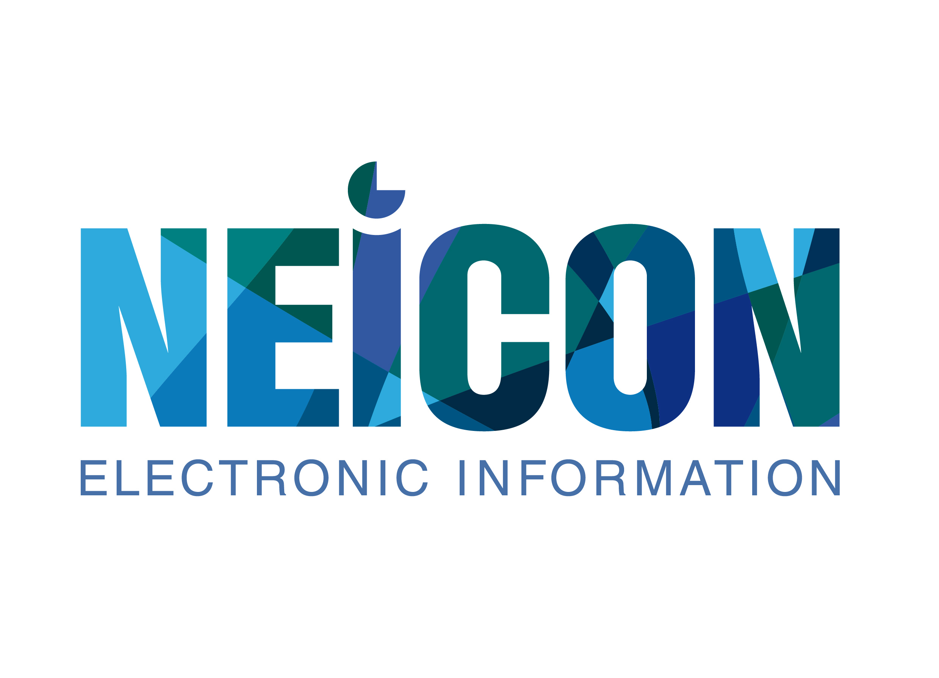
Being a truly national library consortium NEICON currently comprises 1050 members: 40% universities, 40% research institutes and 20 % public libraries. Geography of NEICON members covers more than 120 cities and regions. NEICON is a member of the international organizations EIFL and ICOLC and also of a number of Academic Library Advisory Boards.
Since its beginning NEICON has executed many projects and contracts including those by OSI, Ford Foundation and the Ministry for Culture of Russia. Since 2005, NEICON has been communicating closely with the Ministry of Education and Research of Russia executing contracts on the development of Russian research and HE community.
The NEICON consortium annually provides about 40-50 trainings all over Russia for its nearly 900 member institutions. Staff provides teaching in universities and research institutes. NEICON has launched its own Learning Center (http://school.neicon.ru/) and developed several packages on IL. NEICON annually organizes 3 international conferences on librarianship
Project link: http://neicon.ru/ru/news/422-prodolzhaetsya-realizatsiya-proekta-direkt
Contact: Dr. Irina Razumova
National Electronic Information Consortium (NEICON)
4 bldg 5, of. 2.4, Letnikovskayast
115114 Moscow, Russia
Phone: +7-499-754-99-94
Mobile: +7-9112392490
Fax: +7-499-754-99-94
Email: razumova@neicon.ru
Skype: irinarazumova

P.10 A. Baitursynov Kostanay State University (KSU)
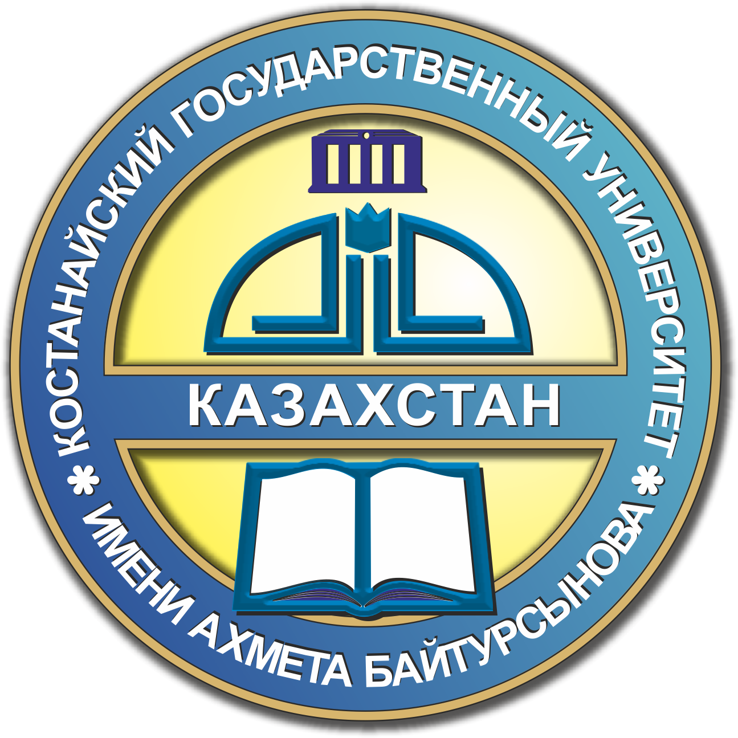
Akhmet Baitursynov Kostanay State University (KSU) is one of the largest higher education establishments and the leading educational scientific and methodological centre of Northern Kazakhstan. It comprises 7 Faculties with 34 Bachelor, 21 Master and 7 PhD programmes. KSU is one of the ten Universities in Kazakhstan involved in the National Program of Innovative Industrial Development. The Participation in the Program stimulates the creation of new master educational programs, fosters the research and contributes to the development of the university laboratory facilities. The trilingual education is being implemented within A. Baitursynov Kostanay State University. Three languages of instruction are used: Kazakh, Russian, and English. The University Library “Bilim Ortalygy” has been improving its image and service, using information technologies. The “Bilim Ortalygy” Library is proud of their good choice and novelty of literature, personnel professionalism, and modern interior. The online network of the University Library includes such resources as Science Direct; ICI Web of Science; Kazakhstani Universities’ E-Library; Kazakhstan Virtual Science Library; Kazakhstani National E-Library; E-Library of “Lan” Publisher, St.Petersburg, Russia.
A. Baitursynov Kostanay State university is involved in the following Erasmus+ projects: LOGON-U Development and Implementation of the Master Programme - “Green Logistics Management“: Advancing Trans-Eurasian Accessibility through Sustainable Logistics Management and ICT Competence, SARUD - Sustainable Agriculture and Rural Development, ECAP - Enhancement of Competencies and Skills of Universities in Central Asia in Agricultural Policy with special focus on Environmental Protection and Land Management, ECCUM - Establishment of Computing Centers and Curriculum Development in Mathematical Engineering Master program, and SusDev - Lifelong Learning For Sustainable Development.
Project link: http://ksu.edu.kz/en/partnership/mezhdunarodnye_proekty_programmy_erasmus_kgu_im_a_bajtursynova/razvitie_informacionnoj_gramotnosti_dlya_obucheniya_v_techenie_vsej_zhizni_i_ekonomiki_znanij_direkt/
Contact: Yelena Kandalina
A.BaitursynovKostanay StateUniversity
Baitursynov St. 47, Kostanay, 110000, Kazakhstan
Phone: +77142390622
Mobile: +77773795579
Fax: +7714251160
Email: ksuintrel@gmail.com or yelenakandalina@yahoo.com
Skype: ksuintrel

P.11 S. Seifullin Kazakh Agrotechnical University (KATU)
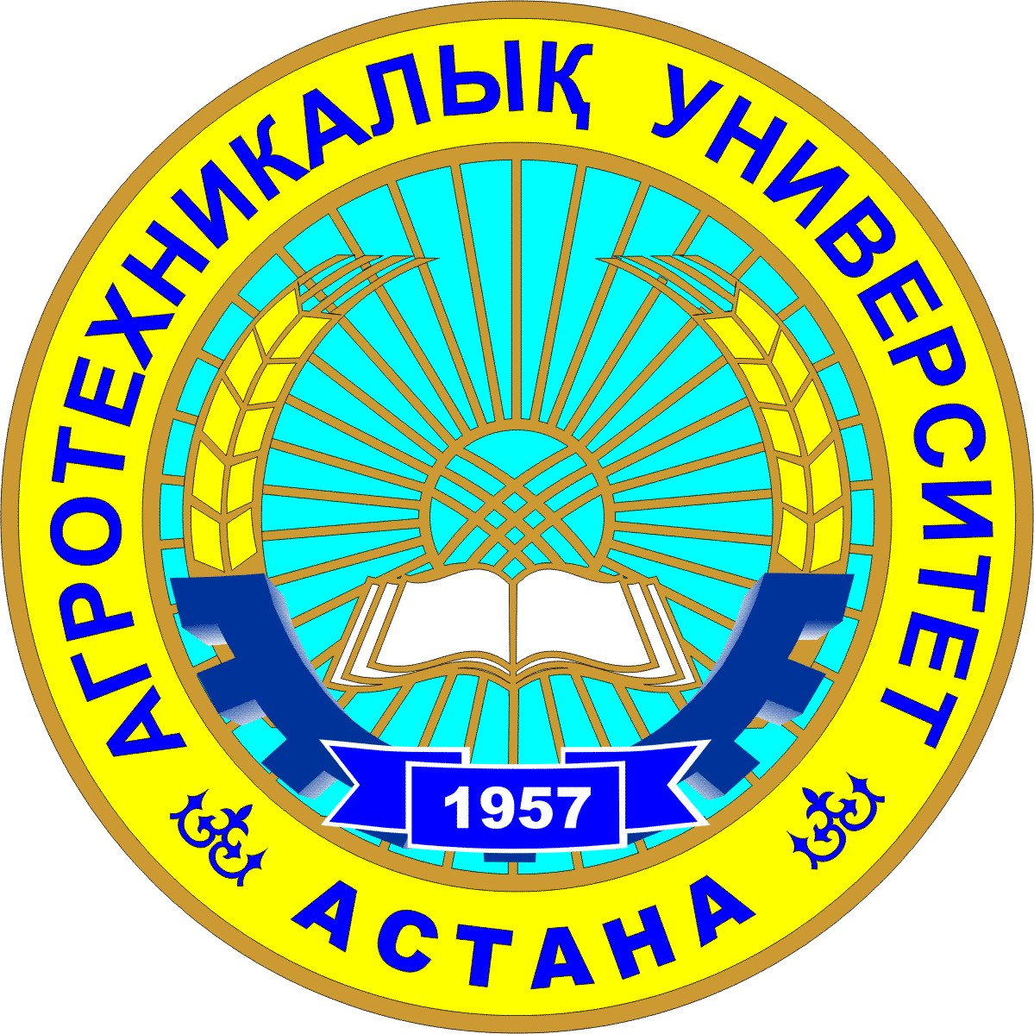
JSC “Saken Seifullin Kazakh Agrotechnical University” (hereinafter - KATU) was founded in 1957. It is the first university in Astana, the capital of Kazakhstan, and one of the largest universities of agrarian profile in Kazakhstan. The mission of KATU is the generation, introduction, distribution and application of advanced knowledge for improving the life quality as well as increasing the competitiveness of the agrarian and industrial complex and other branches of economy. According to the results of international rankings in 2012, KATU is among the 800 best universities in the world. It is one of the ten Universities in Kazakhstan involved in the National Program of Innovative Industrial Development. The participation in the Program stimulates the creation of new master educational programs, fosters the research and contributes to the development of the university laboratory facilities. The number of academic staff is 917 people, including 78 doctors of sciences, 28 PhD, 376 candidates of sciences. The general contingent of students is more than 11 thousand people. Training is carried out on three levels – bachelor, master and PHD degrees, within 85 educational programs (among them 27% of an agricultural profile) in Kazakh, Russian, and English. For the purpose of integration into the world scientific and educational space, the International Cooperation and Multilingual Education Development Center was established at KATU, coordinating the international activities and the expansion of international contacts.
Since 2014, KATU has been implementing a new strategy to reform the modern research university in the field of agriculture. The support for KATU in the implementation of the new strategy is given by the University of California in Davis (UC Davis, the USA), the world's leading research university of an agrarian profile.
The library is an important part of the informational infrastructure of the University. In 2013, KATU library joined the University’s Library Association of the Republic of Kazakhstan (ULA RK). Since 2002, main functions of the library are modified and improved with the help of RFID technology and the "IRBIS" program. Today, the e-catalog includes information about the fund, new books, local and foreign documents, theses, and KATU teachers’ works. The online network of the University Library includes such resources as Scopus; Scival; ICI Web of Science; SpringerLink; CabiAbstracts; Kazakhstani Universities’ E-Library; Kazakhstan Virtual Science Library; Kazakhstani National E-Library; E-Library of “Lan” Publisher, St.Petersburg, Russia. S. Seifullin Kazakh Agrotechnical University is involved in the following Erasmus+ projects: TradPro - Development and implementation of master's programs in food safety, production and marketing of TRADitional food PROducts in Russia and Kazakhstan, SARUD - Sustainable Agriculture and Rural Development, IQAT - Enhancing capacities in implementation of quality assurance systems and typology using Bologna process principles, PAWER - Paving the way to interregional mobility and ensuring relevance quality and equity of access, and SusDev - Lifelong Learning for Sustainable Development.
Project link:
http://kazatu.kz/en/about-the-university/international-cooperation-and-multilingual-education-development-center/erasmus/direkt/

Contact: Saltanat Meiramova
Country Coordinator (Kazakhstan) and Project Management Committee)
S.Seifullin Kazakh Agrotechnical University (KATU)
62 Pobeda Ave., Astana, 010011, Kazakhstan
Phone: +77172384407
Mobile: +77055736482 or +77015332076
Fax: +77172384407
Email: meiramovas@gmail.com or saltanat.m@mail.ru
Skype: saltanat.meiramova

P.12 Al-Farabi Kazakh National University (KazNU)
Al-Farabi Kazakh National University (KazNU) is a leading and large-scale research oriented university, founded in 1934, in Kazakhstan. Al-Farabi Kazakh National University is the only university in the Republic of Kazakhstan which has a unique scientific and innovative structure. Research is carried out in accordance with the priorities of the Republic of Kazakhstan and world trends in science and technology. It has 15 schools with 64 departments, 8 Scientific Institutes and Laboratory of engineering profile of natural area, 5 Scientific Institutes and 30 Scientific Centers of socio-humanity area, 10 Scientific Institutes «GylymOrdasy» and one technopark with business incubator.
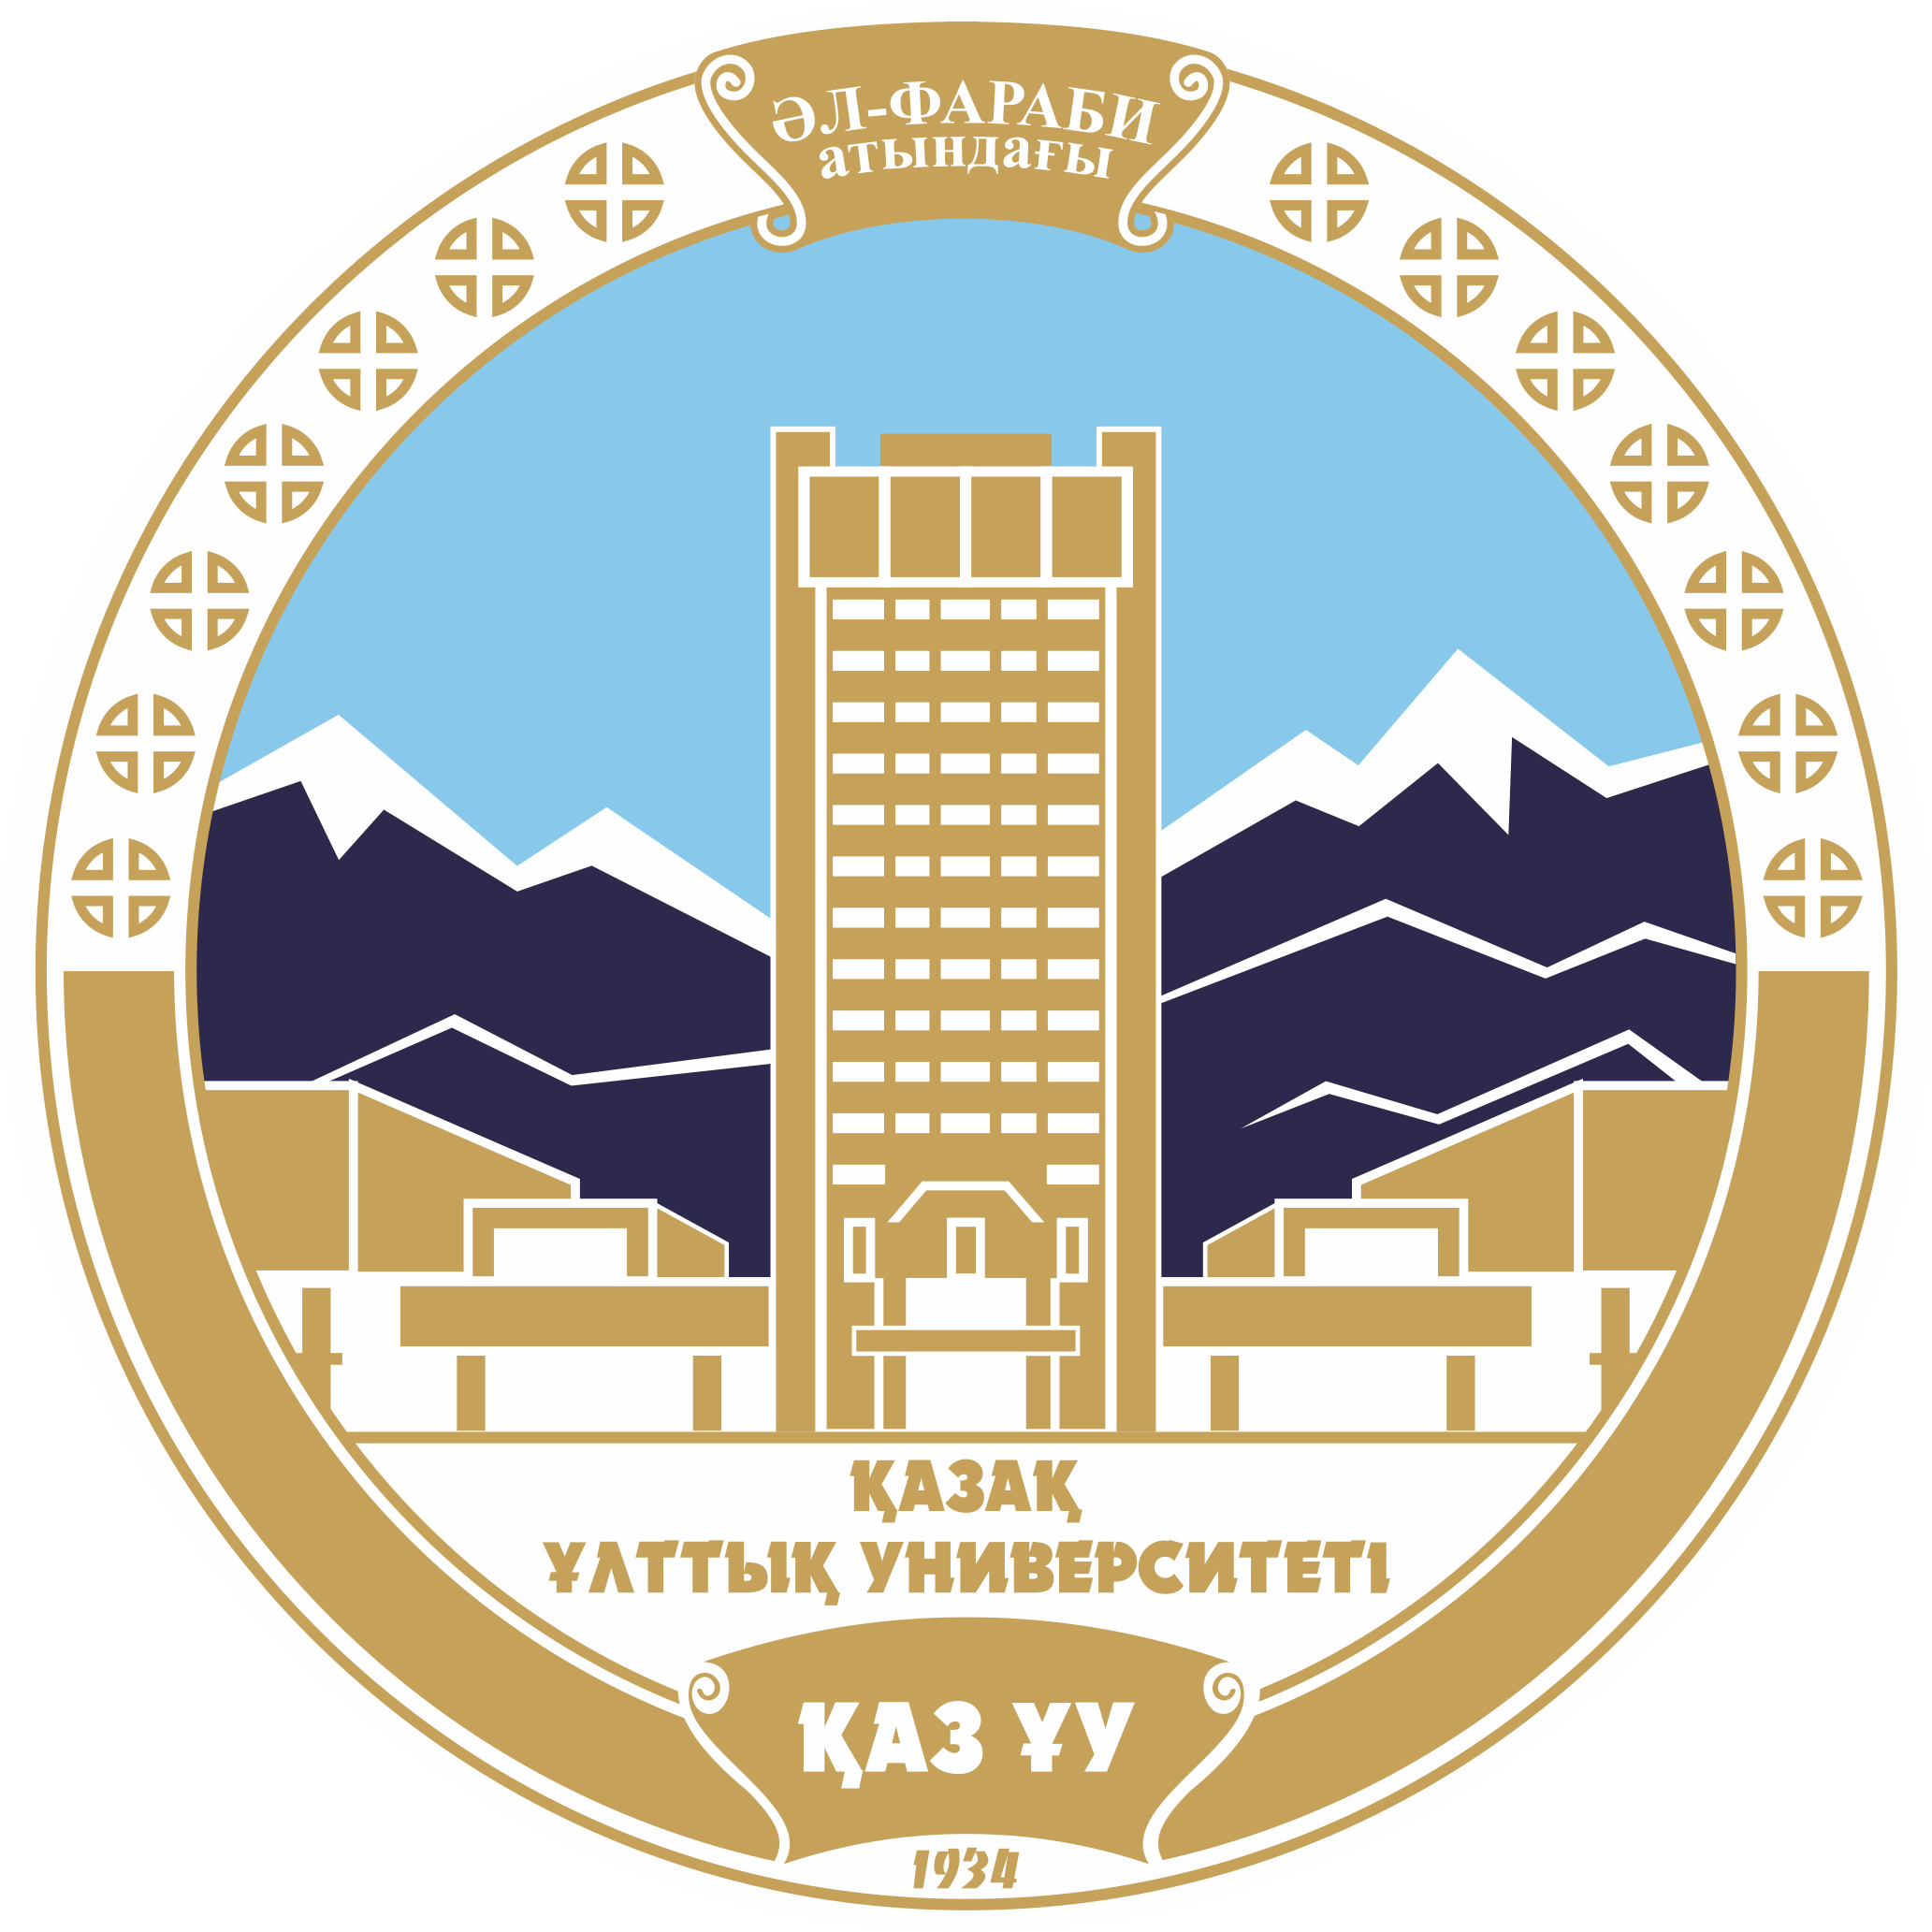
Al-Farabi Kazakh National Library today is one of the oldest libraries of universities in Kazakhstan and among the largest university libraries in the Republic of Kazakhstan, located on the territory of the Kazakh National University. The varied content of the library books fund is universal and has more than 2.5 million different types of documents.
The Electronic Library for information transmission method is divided into zones: graphics, multimedia, audio, video, world resources, and Treasury resources. Library users have access to domestic and foreign electronic information resources and a database of leading world companies: EBSCO, POLPRED.COM, eBooks, IPRbooks, SpringerLink, HSTalks, ProQuest, TheMerckIndexOnline, EASTVIEW, ROYAL SOCIETY OF CHEMISTRY, Science Direct, Scopus (ELSEVIER), Thomson Reuters, Lawyer, Paragraph, etc. The access to sites is limited to IP-addresses of the library.
To carry out various cultural activities the library offers to take advantage of conference facilities and the luxurious hall-foyer of the main building located at the 4th floor of the library.
Project link: http://www.kaznu.kz/en/14971/news/one/11502/
Contact: Yerlan Turgenbayev & Danel Karagoishiyeva
Project Management Committee
Al-Farabi Kazakh National University (KazNU)
71 al-Farabi Ave., Almaty, 050040, Republic of Kazakhstan
Phone: +7-727-221-16-30 & +7-727-221-13-23
Mobile: +77473130145 & +77757546606
Fax: +7-727-377-33-44
Email: lanbay1223@gmail.com & karagoishiyeva.daneliya@gmail.com
Skype: ---

P.13 Beijing Institute of Technology (BIT)
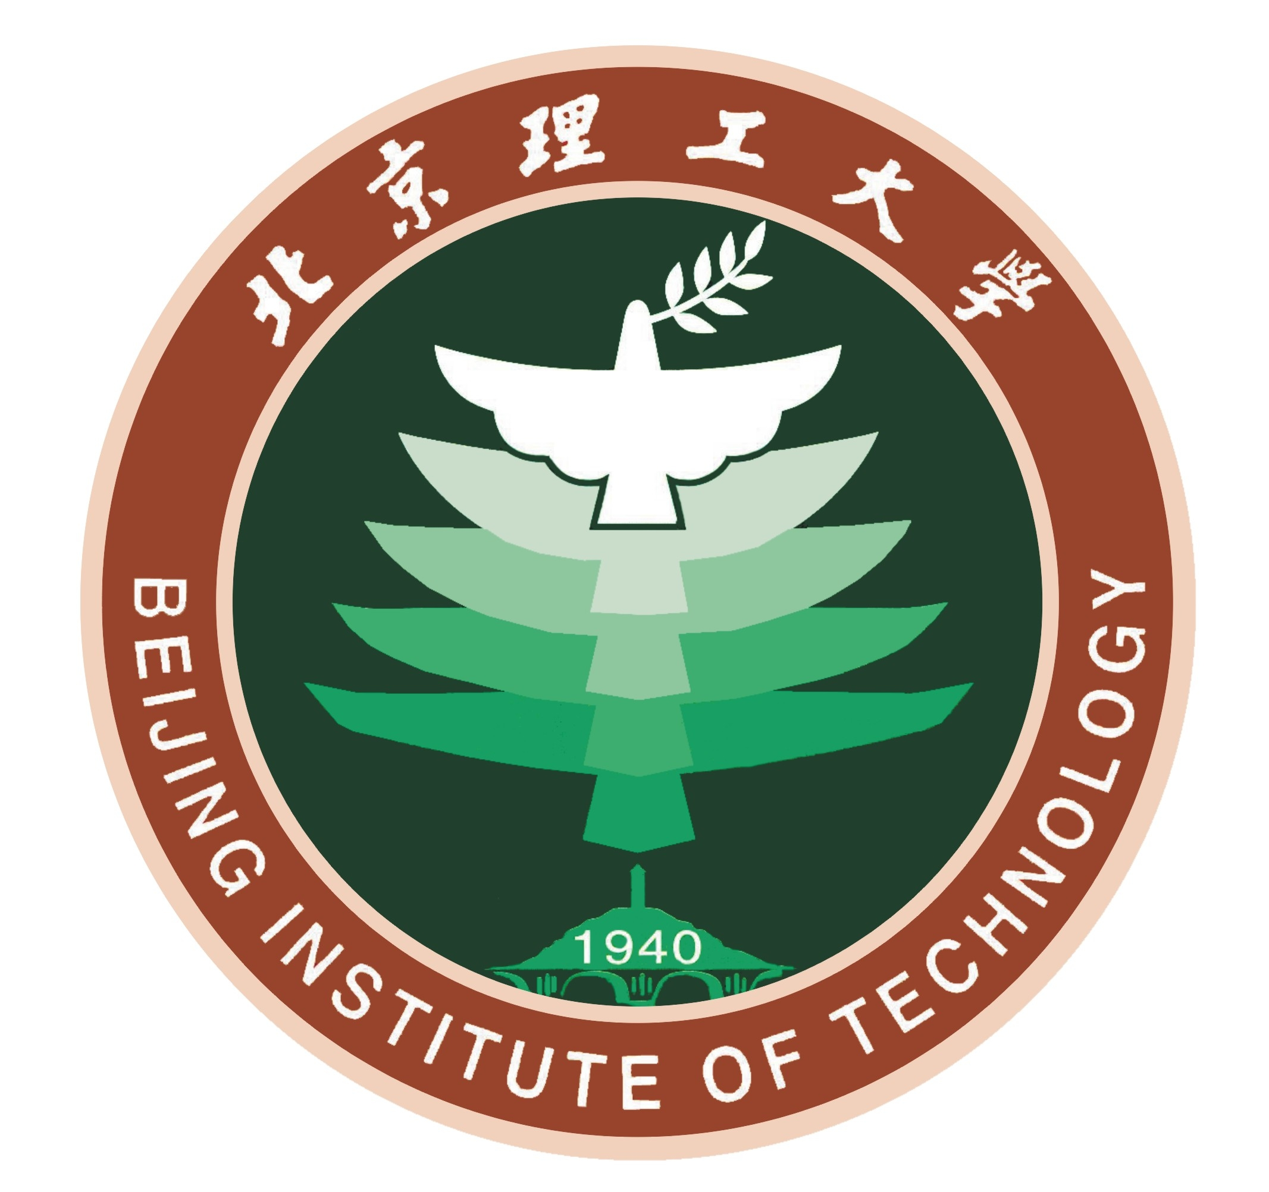
Beijing Institute of Technology (BIT - www.bit.edu.cn) is one of the leading universities in China. BIT is a public university with a traditional focus on science and technology but developing into other areas such as management and humanities. BIT was one of the first 15 universities to join “211 Project” in 1995, which established roughly 100 universities to cope with the challenges of the 21st century. It is the 10th university to enter the “985 Project”, which started in order to develop 39 Chinese universities that would seek to become world renowned universities. BIT is now under the supervision of the Ministry of Industry and Information Technology.
There are four faculties and 19 colleges in BIT, Faculty of Mechanical and Transportation Engineering, Faculty of Information and Electronics, Faculty of Natural Sciences and Materials, and Faculty of Humanities and Social Sciences, as well as the Institute of Educational Research, School of Liberal Arts, School of Continuing Education, School of International Education and Higher Vocational and Technical College, and numerous advanced scientific research centers.
BIT comprises more than 3,500 faculty members and 25,000 full-time students. Over 14,000 are undergraduate students, nearly 8,000 are graduate students and over 3,000 are doctoral students.
Beijing Institute of Technology Library (BITL), originally known as Yan’an Academy of Natural Sciences Library, was established in 1940. It presently consists of Zhongguancun campus library, Xu Teli library (located in Liangxiang campus and named after the BIT’s prestigious former president) and four professional branches covering disciplines from machinery and vehicle engineering, science, humanities to law. BITL’s printed and electronic book collections amount to 2.526 million and 5.4961 million respectively and the library boasts of 273 databases. Moreover, BITL’s featured archived literature system is to be constructed around three programs, namely “Beijing Institute of Technology Special Stacks Center”, “China Association for Science and Technology (CAST) Literature Collection and Exchange Center” and “Collection Base for the Data Acquisition on Senior Scientists’ Academic Journey”. BITL has developed its national defense featured literature resources security system involving wide-ranging disciplines and encompassing both printed and digital documents.
BITL adopts the cross-campus borrowing and reading mode with the principles of “advance ordering, interlibrary loan, resource sharing”. And various modern information service systems have been introduced, ranging from Library Integrated Management System (LIMS), Full-text Electronic Information Delivery System to Cross-Database Retrieval System for Electronic Resources. BITL has achieved the seamless link of library information resources and offered one-stop service to readers to obtain their target information.
Guided by the basic principles of “consolidating present foundation, developing with its own characteristics, adopting library technology, and innovating service offerings” and equipped with automotive management system, BITL will employ more skilled staff and pay more attention to the discipline construction so as to provide high quality information services to regular class teaching and scientific research. Supported by advanced technology, BITL is expected to become an efficient, digitalized, research-oriented university library with good domestic and international reputation.

Project link: 北京理工大学机械与车辆学院
Contact: Dr. Xu Zhang
Associate Professor, School of Mechanical Engineering
Beijing Institute of Technology (BIT)
5 South Zhongguancun Street, Haidian, Beijing 100081, China
Phone: +8610-68918689
Mobile: +86-133-1132-0309
Fax: ---
Email: zhangxu@bit.edu.cn or xuzhang05@yahoo.com
Skype: lavazoom

P.14 Northwestern Polytechnical University (NPU)
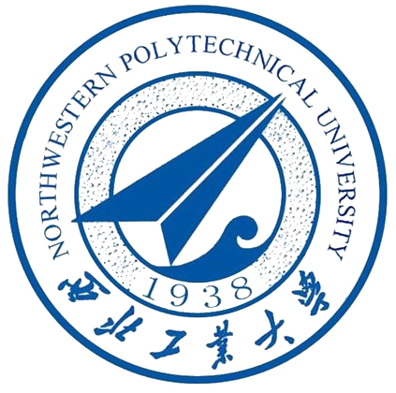
NPU is located in Xi’an, the cradle of Chinese civilization, and starting point of the ancient Silk Road. NPU is classed as a key university in China’s 985 and 211 Projects.Originally founded as the State Northwest Polytechnic Institute in 1938, NPU has developed into an open and research-oriented University by bringing its founding spirit of inquiry and innovation into a wide-ranging curriculum that now includes the Humanities, Law, Management and Foreign Languages. And by incorporating three of China’s leading engineering schools, NPU has gained international recognition for its work in the fields of aeronautics, astronautics, and marine technology. Over more than 70 years NPU has built an outstanding academic reputation encapsulated in its motto of "Loyalty, Integrity, Courage and Perseverance".
The library takes a total area of approximately 46,000 square meters consisting of an eastern and western part on Youyi campus as well as the library on the Chang'an campus. The new library on Chang’an campus was designed as a comprehensive research modern university library providing integrated services of collecting, lending, reading and studying. It has a capacity of 1,600,000 books and 4,000 reading seats.The library provides the readers with services such as information retrieval, scientific and technological consults, novelty searching, and appraisal. It keeps in regular contact with the international and domestic book and intelligence community, lends and borrows from each other and shares the documents in their original languages. Now there are 69 librarians, including 21 at or above an associate professor level, 30 with intermediate professional title. The library serves more than 4,000 faculty and over 30,000 students at the university. The NPU library is now undergoing a transition from a traditional library to a modern one. There is determination by the library staff to create more opportunities, provide a wider variety of services and strive for the goal to make the library a first-class one that will become internationally well-known.
Project link: http://jidian.nwpu.edu.cn/info/1039/7575.htm
Contact: Wang Shuxia
Associate Professor
Northwestern Polytechnical University (NPU)
127# YouYi Xilu, Xi’an, 710072 Shaanxi, P.R. China
Phone: +86-29-88494457
Mobile: +86-17742499375
Fax: +86-29-88494457
Email: 2008wangshuxia@163.com
Skype: Shuxiawang2011

P.13 Nanjing University of Science and Technology (NUST)
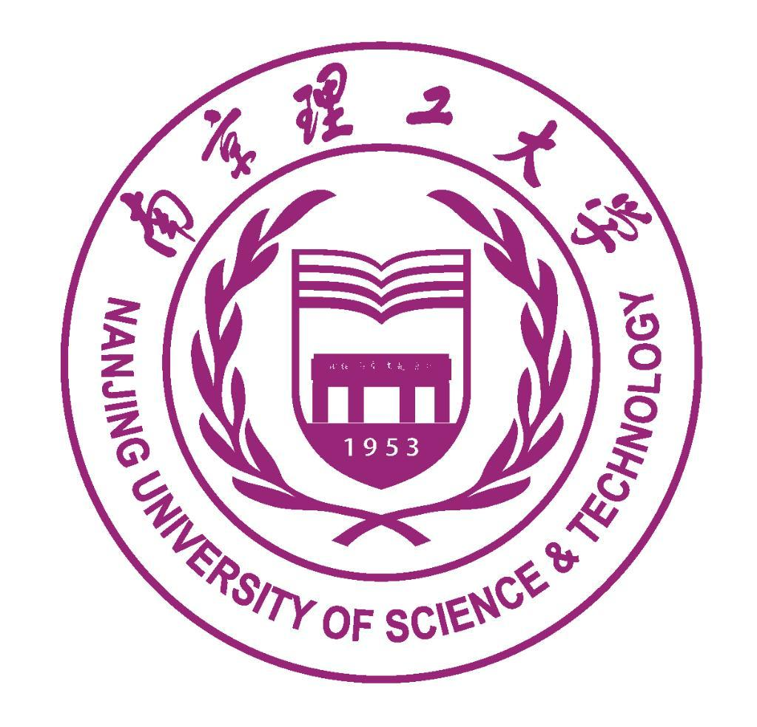
NUST, founded in 1953, is one of the key universities in China under the guidance of the Ministry of Industry and Information Technology. It is listed in the first group of universities chosen to be part of China's "211 project", which is designed to develop a hundred first-rate universities during the 21st century. NUST is a multi-disciplinary university incorporating science, engineering, liberal arts, economics, business, management, law and education with special emphasis on engineering. The university is composed of 15 main schools offering 49 doctoral programs 116 master programs and 70 undergraduate programs. The number of students is over 30000, including 47% graduates and 53% undergraduates, and nearly 600 international students. In six decades, the University has trained over 100000 senior professional personnel of all kinds, who are prestigious and influential in the society. Following the NUST globalization strategy, most of the programs for local students are available for international students.
NUST Library was established in 1960 and moved to a new building in 2010. Its collection is abundant and covers wide subjects. The collection of Atmospheric Science is one of the most complete libraries of the Academic Library in China. Currently, the total printed collection amounts to more than 1.47 million volumes, annual subscription to the printed Chinese and foreign periodicals amounts to 1,786 kinds. Core journals including Atmospheric Science, Environmental Science and Engineering, Information Science and Technology, Computer Science and other disciplines, have a complete collection.
Project link: http://sme.njust.edu.cn/3b/8e/c1708a146318/page.htm
Contact: Prof. Teng Yan
Dean of Mechanical Manufacturing Automation Department &
Prof. Tong Yifei
Vice dean of Industrial Engineering
Nanjing University of Science and Technology (NUST)
Xiaolingwei 200, Nanjing, China
Phone: +86-25-84315150
Mobile: +86-13913883508
Fax: +86-25-84315181
Email: yantengwf@126.com & tyf51129@aliyun.com
Skype: yantengwf@126.com

Project activities

Project activities/developments:
The DIREKT project commenced with the Project Kick Off- PMC meetin held in Petrozavodsk (Nov 2016) in conjunction with ESP training. At the Kick Off meeting criteria and procedures for communications between partners, management and decision making structures and the functions of the Working Groups and Local Committees, and local project coordinators have been agreed. All partners signed the Consortium agreement which ruled relations, methods of cooperation, disagreements, planning meeting agenda and the identification and agreement of control procedures as well as problem solving procedures.
Preparation in the project involves the implementation of intensive, in depth Information Literacy Needs detection + Competency mapping; IL Strategic Review.
The Development phase of the DIREKT project commences with ESP Training (Information Literacy, Library and Academic Writing terminology) followed by the preparation of an ECTS Module Training Programme using the EU Tuning Method. This is followed by DIREKT Curriculum Training in Limerick, Piloting of DIREKT Curriculum + Evaluations 1 + 2 of the Pilot.
Quality will be ensured through the formation of the Evaluation Working Group (EWG) comprised of 5 experts in quality contol and monitoring as well as the evaluation of the DIREKT Curriculum and Quality Assurance (QA) reports. Dissemination/sustainability activities include the Public Presentation of the DIREKT project in PC's, National IL Awareness Seminars in RF, KZ, CN, DIREKT modules testing and integration, the DIREKT Online Platform, Final Project Conference & an Awareness Seminar.
The plan is to develop training programmes supported by ECTS modules (both hard copy in script form and online on the project website platform) and embedded in curricula in the PC universities as well as the involvement of other stakeholders such as National/Public Libraries to ensure maximum transfer effect to society at large.

Training Content and Pedagogical Approach:
In each case, the required methodological approaches needed with respect to how to teach are determined and meet the needs of main stakeholders. In this way, each partner designs bespoke training programmes to best meet their target market (i.e., academic + library staff, students, student teachers, policy makers, public librarians, etc) enabling flexible and responsive solutions that stem from an agreed set of principles and enabling all needs of PC universities to be addressed. The pedagogical approach stresses a communicative and skills teaching approach. Following our needs analysis of the Information Literacy/Library/Academic Writing situation in the PC countries the following modules were identified which form the DIREKT Curriculum:

LNSS CURRICULUM MODULES:
Module 1: English for Specific purposes (Libraries, library terminology and library access): this is targeted at all partners and will be integrated into official university structures and where feasible public and National libraries.

Module 2: IL Marketing skills for Academic staff librarians: Theory and practice – Creating IL Awareness Campaign Strategies to address all Stakeholders
Module 3: Information Literacy 1: for Librarians to train them to help learners find and use information effectively and ethically. This module will cover:
•International Information Literacy Standards: SCONUL, ACRL, ALA, ANZIL
•Focussing and Defining your Research Question
•Using Online Information Literacy Modules for teaching Information Literacy
•Mind the Information Gap! Knowing the critical information sources and resources
•Critically analysing information resources
•Referencing Citation and Avoiding Plagiarism
•Introduction to the Literature Review
Module 4: Information Literacy 2: for Librarians to train them to help Learners access information online and in print, to liaise effectively with Library users to enhance their pedagogical and teaching skills
•Using Electronic Library Databases for your research
•Evaluating sources of information
•Web & Internet search strategies for the Information Age
•Using Library Bibliographic software for your referencing and research
•Becoming a Subject Liaison Librarian: skills for collaborating with Academic staff
•Information Literacy for Business & Entrepreneurship
•Train the Trainer: Teaching and pedagogical skills for Librarians

Module 5: Information Literacy 3: Innovative online library services for 21st Century Librarians: aimed at librarians to help them develop new innovative online library services for Information Literacy:
•Designing library web sites and online platforms and portals
•Online Public Access Catalogues (OPAC)
•Web 2.0 Technologies and Social Media for libraries
•Library Mobile "Apps" ("M-libraries")
•Virtual Reference and Ask a Librarian Services
•Electronic Documents Delivery and Inter Library Loans
•Federated search: new options for libraries in the Digital Age
•Using LibGuides for Library research and Information Literacy
•Introduction to Open Access and Open Source for Information Literacy
•Getting the most from Institutional Repositories

Module 6: Information Literacy & Academic Writing 1: RELATING INFORMATION LITERACY TO ACADEMIC WRITING
•Study skills for Academic Writing (Time management, Reading and Note Taking)
•Developing critical analysis: the cognitive domain
•Basic Principles of Written English (proofreading and self-editing; revision vs. editing; common errors in grammar, punctuation, and spelling; understanding tone and diction; vocabulary development)
•Structuring and Writing Theses, Dissertations, Essays, Reports and Abstracts
•Line by Line- Academic Writing and the process of composition
•Academic Writing for different disciplines(e.g. writing for science and engineering, humanities, the Social Sciences).

Module 7: Information Literacy and Academic Writing 2:
•Information Literacy and Educational Technologies, Digital Publications Tools and other Technical Aids for Academic Writing
•Information Literacy and Research data management
•Academic Career Planning and Academic Writing: developing your career beyond Academia
•Information Literacy & Getting Published
•Dealing with your Research Supervisor
•Information Literacy, Research Ethics and Academic Writing
•Project management skills incorporating Information Literacy Academic Writing and Research projects
•Conferencing, Networking skills for Information Literacy.
•Writing for funding: writing effective funding applications for your University
Online modules will be created for each PC institution in the project and localised for the needs of the particular country, area or institution to complement regular classes using a blended learning approach involving the use of online assessment exercises and active learning.
We will be mindful of measurable indicators such as numbers of Library/Academic staff/students attending the courses and successful embedding and integration of IL into curricula at PC institutions.

Timeline

Workplan
Year 1
1.1 Training and general Library Needs Detection + Competence Mapping
1.2 Strategic review of Information Literacy
2.1 English for Specific Purposes (ESP) Training
2.2 Guidelines for Planning IL Programs
2.3 Preparation of ECTS Module Training Programme using EU Tuning Methods
2.4 Defining IL Program Harmonised Contents
3.1 Defining training of IL Practitioners
4.1 Agreement Library Online Module Guidelines and Process
4.2 Development and Delivery of the Online IL Modules
5.1 Project Management and Evaluation
5.4 Quality Assurance Reports
6.1 Public Presentation of the Project
6.5 LNSS Online Platform
7.1 LNSS Project Coordination Reports
7.2 Project Management Plan and Structures Agreed

Year 2
2.5 Guidelines for IL Program Harmonised Contents
2.6 Production of IL program Harmonised Materials
3.2 Guidelines for Training of IL Practioners
3.3 DIREKT Curriculum Training
3.4 Pilot 1 of DIREKT Curriculum
4.2 Development and Delivery of the Online IL Modules

5.4 Quality Assurance Reports
6.2 Mass Media Campaign- National IL Awareness Days implemented by DIREKT IL Action Group
6.5 DIREKT Online Platform
7.1 DIREKT Project Coordination Reports
7.3 Intermediate Review of Project Management
Year 3
3.4 Pilot 1 of LNSS Curriculum
3.5 Pilot 2 of LNSS Curriculum
4.2 Development and Delivery of the Library Online Modules
5.2 Evaluation of Pilot 1
5.3 Evaluation of Pilot 2
5.4 Quality Assurance Reports
6.3 Models and DIREKT Training Methods Dissemination
6.4 Sustainability – DIREKT modules are tested, adjusted, integrated
6.5 DIREKT Online Platform
6.6 Final DIREKT Project Conference
7.1 DIREKT Project Coordination Reports
7.4 Final Review of Project Management

Project management

LIT will undertake activities to ensure sound management of the project and will perform the duties of authorising officer and Coordinator of the project.The PMC will measure the progress and results of the specific activities during their realisation of the project in each organisation using performance indicators established by the Evaluation Working Group (EWG). The EWG will evaluate all possible incoming problems and their impact on project activities. It will address and evaluate problems such as delays, lack of resources, underestimated necessary efforts and any other risks or problems which inhibit the delivery of IL programs and will propose possible solutions. Resolution may be aided by improving management and organisation of activities or by re-clarifying project procedures.
DIREKT has a very clear Monitoring and Management plan and management structure to ensure permanent and effective communication and reporting. The PMC is responsible for the control of the administrative and methodological aspects of the project. The PMC consists of members from all partners in the project. There is an LIT Project Management Team consisting of the Project Leader (PMC Chairperson); Project Coordinator; Finance Coordinator. Under PMC there are various Working Groups (WG's) DSWG, ILTWG, ILMWG, EWG - whose work is to ensure all the deliverables in the project are highlighted and met on time. All products, results emanating from WG's must be communicated to and ratified by PMC. Roles, methods and day to day operations will be defined by the Consortium agreement.
In addition to the PMC meetings involving all partners (1 meeting per year over 3 years), the Project Management Committee (PMC) will hold regular monthly project management meetings covering progress towards objectives, coordination and financial control. The regular meetings, supplemented by further ad hoc contacts as necessary, ensure timely tender procedures and purchasing and distribution of resources to all partner universities.
EU partners will conduct termly video conference and monitoring and evaluation visits. Each EU partner will create Evaluation Reports to be forwarded to the Grant Holder after each termly monitoring video conference and after each monitoring visit.
Final Decision Making and Conflict Resolution is the responsibility of the PMC; the PMC will be responsible for:
-Control of the administrative and methodological aspects of the project.
-Monitoring and evaluation of project phases including communication regarding expectations of partners and stakeholders and with declared objectives.
-Intervention for problem solving.
All decisions of Working Groups (DSWG, ILTWG, ILMWG, EWG) must be ratified by the PMC as the decision making body of the Consortium.

Cooperation and Communication

Project Management is organised and acts in order to ensure the achievement of project results and the accuracy of procedures. Allocation of resources: A Project Management Committee (PMC) are established at the beginning of the project as well as Working Groups and Local Committees. The PMC consists of 2 contact persons (1 member of Management/academic/library staff and 1 administration staff who is directly involved in activities).
The Coordinator of the PMC (LIT) ensures that the project objectives are clearly highlighted and met and implements procedures for the efficiency of the project. PMC conducts coordination meetings, once a year, 4 days, every year & conducts monthly management meetings (Web Conferences). The PMC steers the project & intervenes as necessary to readjust the project to the context, ensure consistent communication between partners and the organisation of Committee meetings. Working Groups are formed to ensure that the specific roles and tasks are distributed effectively:
Didactic and Scientific Working Group (DSWG)
Information Literacy Training Working Group (ILTWG)
Information Literacy Module Working Group (ILMWG)
Evaluation Working Group (EWG)
Each WG meets 3 times during project lifetime - once per year & reports to the PMC via Chairs of WG's and the use of Web Conferencing for some meetings.
Local activities of partner universities and non academic/society partner (e.g. exchange of information, training, equipment etc.) are supported by the contact person for each partner. The contact person champions and highlights the project objectives & coordinates human resources for the success for the project. Working Groups ensure the various components of the project – management, development, quality control etc. are followed through effectively. Roles, methods etc are defined by the Consortium agreement.
Each partner is represented on each Working Group and Committee of the project. Tasks are distributed equally and fairly as follows:
MRSU + KATU + NUST + LIT: Lead Preparation WP.
TUD & UKF: Lead Didactic & Scientific Organisation WP
TPG & LIT: Lead Information Literacy Curriculum Training, Piloting WP
LIT: Lead Online IL Module Development
UKF: Lead Quality WP
NEICON + KSU + BIT + TPG : jointly lead Dissemination + Exploitation WP
LIT: Lead Management WP
Other RU, KZ & CN partners participate in Working Groups and form local committee structures to ensure the dissemination of project results and the implementation of project initiatives in PC universities and in society at large. This is achieved through local program committees, the participation in design & delivery of the DIREKT Curriculum, running of Information Literacy trainings & workshops, trainings of trainers and by helping form networks of experts & enthusiasts in PC‘s Universities and locally to enable awareness and rollout of the new initiatives in RF, KZ, CH HEI's and in Society.
Project ownership is ensured as both EU and PC institutions particiapte and contribute to the design and the implementation of the DIREKT Modular Curriculum although this process is led by EU partners, particularly TU Dresden & LIT. EU partners also implement the English for Specific Purposes training as part of the DIREKT Curriculum Training.
PC institutions are involved in the design, pilot, evaluation, accreditation & dissemination of the DIREKT project & DIREKT Curriculum supported by RU partner NEICON & Associate Partners Arbicon, CSL (KZ), and CNIC (CN). They promote DIREKT in their universities, cities, regionally and will work together and disseminate at national level. A strategy for Cross Border Relations is drafted at the beginning of the project and agreed by all RF, KN, CN partners so as to ensure good cross border communication and dissemination incorporating Associate Partners.

