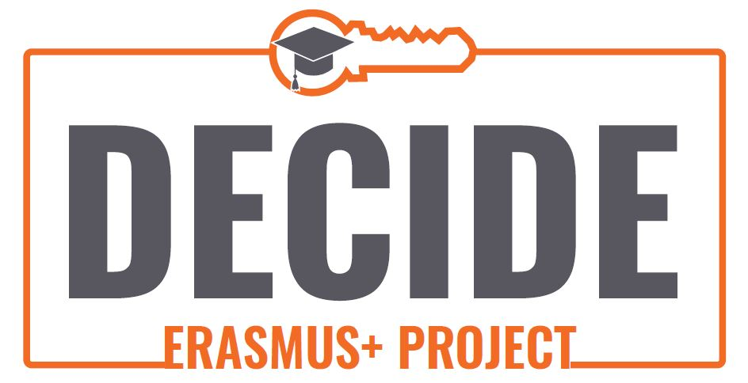

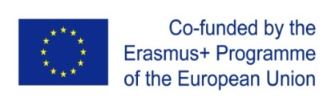

DECIDE CBHE PORJECT:
Developing Services for Individuals with Disabilities

About CBHE

CBHE is the European Union’s programme whose aim is to improve, develop, and modernise higher education systems and to support cooperation of Partner Countries across different regions of the world such as Eastern Europe and (Central) Asia mainly through university cooperation projects.
The DECIDE project has been funded by the European Commission through the Capacity-Building in Higher Education Programme (CBHE) as part of the Key Action 2 projects.

Technische Universitat Dresden

The Technische Universität Dresden, (TUD), is one of the largest technical universities in Germany and is a full university with 14 faculties including medicine, pedagogy etc. As a former part of the Soviet bloc of East Germany, TUD has significant experience working with universities from the central European and former USSR regions. It is fully compliant with German laws relating to persons with special needs and its campus is a role model for special needs access, and staff and student support. TUD has extensive EU project experience having been involved in numerous Tempus and CBHE projects. TUD is growing by the diversity of its members and is committed to inclusion, running a long-term programme to enhance inclusion. The aim is to allow the fair, non-discriminatory and self-determined participation of people with disabilities and chronic illnesses in all subjects within the university and their ability to contribute to the development of an inclusive university. For more information please see the following link:

https://tu-dresden.de/tu-dresden/chancengleichheit/?set_language=en

The DECIDE Project
http://www.decideproject.ie/

The specific objectives of the project is the Three Strand Implementation of a comprehensive sustainable curriculum for Teacher Trainer Educators and Lecturers (Universities), secondly for Government & State Employee & Policymakers, and thirdly, for NGO in the PC'S. This will foster the right of individuals with special needs to access education, enjoy the right of participation in everyday society and to combat discrimination by instilling awareness and acceptance in society as in line with Bologna Process and the UN Convention on the Rights of Persons with Disabilities. This in turn facilitates the creation of the Access Liasion Officer role at each institution to promote disability access, and the National Special Needs Awareness Day focus via the nationally strategic Action Groups comprised of universities, public administration institutes, Ministries and NGOs.

The project will promote and develop access to inclusive education, to social integration and to non-discrimantion treatment of those with special needs in education in accordance with Bologna Process and UN criteria. This will initiate the right of individuals with special needs to access education, to enjoy the right of participation in everyday society and to combat discrimination against them in society by instilling awareness and acceptance in society.

Principal outcomes and outputs incorporate English for Specific Purposes (Special Needs and Disability) training for all target groups, DECIDE ECTS training, a complete DECIDE Curriculum for all PC institutions (developed with EU-TUNING), a piloting of 8 DECIDE Introductory and Advanced Modules (see Project Content) through Piloting during 2 semesters.

The Quality Plan aspects focus on monitoring and evaluation of the 8 module Curricula, and of both the dissemination/sustainability friendly "Action Group" (who will create the 10 year National Awareness Day in both countries) and the "Access Liasion Officer" (helping students with special needs issues in each tertiary organisation) Strategic Review and the Integration Process of National Students Union Participation.

This is all overseen by a total quality management via project structures and meetings and daily project management
-to promote and develop access to inclusive education, to social integration and to non-discrimination treatment of those with special needs in education in accordance with Bologna Process criteria and UN Convention on the Rights of Persons with Disabilities.
-to create, pilot and implement a comprehensive training curriculum.

Project Activities and Methodology

TU Dresden is one of the primary partners in the DECIDE project, helping to design, and deliver, the negotiated training programmes using in-house expertise and experience of such activity. We are
involved in evaluating the piloting and implementation of modules. In the Development of the DECIDE project TUD has a lead role in the area of English of Specific Purposes Training, DECIDE Curriculum Training and the planning and operation of Piloting, Marketing, and the provision of ECTS and Tuning training.

Academic Content and Pedagogical Approach: The plan is to develop training programmes supported by ECTS modules (both hard copy in script form and online on project website platform) and embed in curricula in university, training of Civil Servants from various relevant Governmental Bodies and in special needs NGOs to ensure maximum transfer effect to society at large.

The four aspects of need identified for the PC societies from our analysis are:

1) Communication and Interaction (which would include Autism)
2) Cognition and Learning (including moderate and severe learning difficulties and Dyslexia)
3) Social, Emotional and Behavioural Difficulties
4) Sensory and Physical needs

From this stating point we will determine in each case the required accessibility, assistive technology, and methodological approaches needed with respect to how to teach, and meet the needs of persons with disabilities. In this way, each partner will design bespoke training programmes to best meet their target market (i.e. student teachers, policy makers, librarians etc.), enabling flexible and responsive solutions that stem from an agreed set of principles and enabling all areas of disability to be addressed. The pedagogical approach will stress a communicative and skills teaching approach. This project seeks to introduce a practical and theoretical based approach using learner-centered strategies in creating a focused 8 module programme that is fully compliant with ECTS and EU Tuning tools. It will employ modern best practice case studies and simulations to maximise the learner benefit and promote critical and creative thinking in this special area; The Introductory Modules are as follows.

SPECIAL NEEDS INTRODUCTORY (PRACTICAL) MODULES - ALL NON-EXISTING AT PC UNIVERSITIES

Module 1
English for Specific Purposes (Special Needs and Disability) - This is targeted at all partners and will be later integrated into official university and public administration and where feasible NGO programmes.

Module 2
Marketing - Introduction to Theory and Practice - Creating National Awareness Campaign Strategies and Supporting NGO Development

Module 3
Use the Library! - This is targeted at all partners and especially librarians given the potential as underlined by Repanovici Angela- UTBV assessment on integrating disabled persons very effectively into society.

Module 4
Access Liaison Officer Trainee Programme Module - Targeted at all partners with inputs from all partners and the basis for the future Action Group. This training module will ensure that each educational organisation will have a specialised person in social integration and anti-discrimination measures on advising and assisting students or potential students with special needs in accessing education.

SPECIAL NEEDS ADVANCED MODULES (Theoretical Special Needs and Disability Specific) ALSO NON-EXISTING

Module 5 Meeting Needs - Cognition and Learning (including moderate and severe learning difficulties and Dyslexia)

Module 6 - Meeting Needs - Communication and Interaction (which would include a focus on Autism as identified by the SWOT analysis)

Module 7 - Meeting Needs - Physical and Sensory Needs

Module 8 - Meeting Needs - Social, Emotional and Behavioural Difficulties

Here we will create ECTS modules using the EU Tuning method whilst Module 1 materials will be modified into the Common European Framework for later university, Governmental Bodies and NGO use.

All participants in Work Package 1 will be required to have Upper Intermediate knowledge of English in order to be taught societal English course focusing on new vocabulary and necessary soft skills to achieve project goals.

The involvement of our key stakeholders emphasize that the project will ensure that both private and public sectors respect the rights of individuals with disabilities and involvement in society. Ministries of Education and Social Services, Teacher Trainer Educators (Universities) and their student teacher target group, Government & State Employee and Policymakers and NGOs including volunteers, social workers and parents (Non-university teachers). By the end of the project knowledge, public awareness and commitment among duty bearers (teachers, authorities, politicians and parents) has increased and the communities have embraced more inclusive and proactive approaches to disabled persons' welfare.

Primary and secondary schools in the PC countries will be systematically informed. Informing other non-Consortium universities (both public and private) and authorities (national, regional and local) and NGOs in the PCs and the ethical and practical range of benefits to all parties involved will enhance a sense of ownership and motivation during and after the project.

The ACTIVITIES leading to the LFM outputs/outcomes are:

DECIDE pedagogical training for Partner Country University, public administration government employee and NGO personnel, in EU and PC.

Development of English for Special Needs materials

Preparation of 3 strand pilot DECIDE curriculum of above mentioned 8 Modules

Production of 3 strand training of 8 modules complying with ECTS modular standards

Pilot 1 - pilot of training modules

Evaluation of pilot 1

Pilot 2 – 2nd pilot of training modules (including Train the Trainer programme used to train Civil Servants and representatives of relevant NGOs by the University staff who received the special training in EU)

Evaluation of pilot 2 and downloadable access

Formal integration of ECTS DECIDE modules by PC institutions, ie Universities, Public Administration institutes and NGOs following Ministry approval.

DECIDE: Developing Services for Individuals with Disabilities

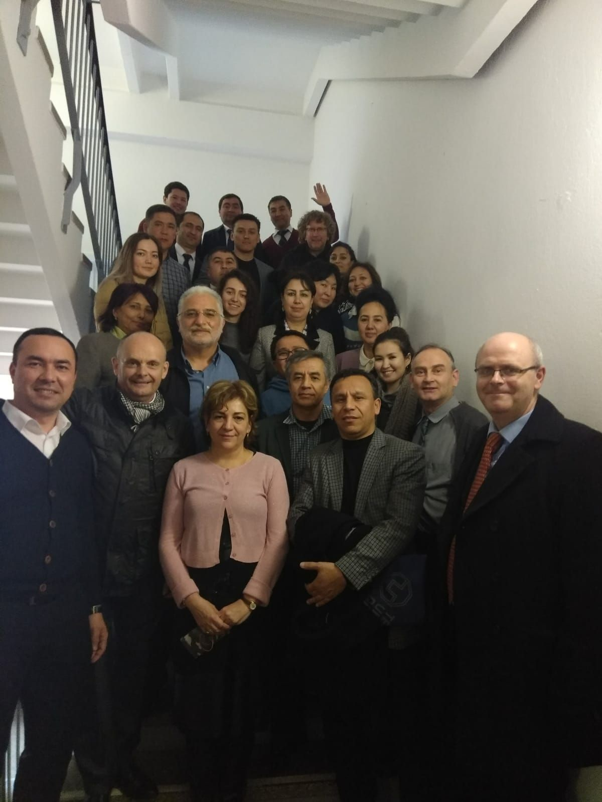

English for Specific Purposes Training at Dresden Technical University

The Centre of Applied Languages and Culture (SLK)

March 23-29, 2019

Partner Universities and Institutions in the DECIDE project

EU Project Coordinator:
P1 Transilvania University of Brașov (UTBV), Romania [Lead Partner]
Professor Dr Angela Repanovici

https://www.unitbv.ro/en/

Other European Partners:
P2 Middlesex University (MDX), UK
Dr Nawaz Khan

https://www.mdx.ac.uk/global-impact

P3 Limerick Institute of Technology (LIT), Ireland
Jerald Cavanagh BSc Econ, MSc, MA

http://www.lit.ie/LearningSupport/default.aspx

P4 Technische Universitat Dresden, Germany
Sven Riddell MA

https://tu-dresden.de/

P18 University of Crete (UOT)
Dr Manolis Koukourakis

http://en.uoc.gr/

Central Asian Partners:

P5 Samarkand Institute of Economics and Service (SIES), Uzbekistan
Ms. Dilbar Aslanova

http://sies.uz/en/malumot/view?id=131

P6 Tashkent University of Information Technologies (TUIT), Uzbekistan
Mr Javlon Abdujalilov

https://tuit.uz/en

P7 Karakalpak State University (KSU), Uzbekistan
Dr. Bakhitbay Paluanov

http://karsu.uz/en/

P8 MUSHTOQ KO’ZLAR Society of social mutual aid of disabled children (MUSHTOQ)
Mr. Umidjan Khashimov

P9 Seifullin Kazakh Agrotechnical University (KATU), Kazakhstan
Mrs. Saltanat Meiramova

http://iac.kz/en/sseifullin-kazakh-agro-technical-university

P10 Al Farabi Kazakh National University (KazNU)
Dr Gainel Ussatayeva

http://iac.kz/en/sseifullin-kazakh-agro-technical-university

P11 A. Baitursynov Kostanay State University of Ministry of Education and Science of the Republic of Kazakhstan (ABKSU), Kazakhstan
Prof. Shushanik Sarkisyan

http://ksu.edu.kz/en/

P12 The Academy of Public Administration under the President of the Republic of Kazakhstan (APRK)
Mr Aibek Sagynayev

https://www.apa.kz/en/

P13 Affordable Education for Students with Disabilities (AESD)
Professor Sarkisyan Shushanik

P14 Khujand State University namd after academician B. Gafurov (KSUBG), Tajikistan
Mr Jamshedjon Istamkulov

http://hgu.tj/

P15 Kulob Institue of Technology and Innovation Management (KITEM), Tajikistan
Mr Almossho Nabotovich

P16 Public Administratin Institute under the President of Tadjikistan (PAI), Tadjikistan
Mr Abdulkholiqzoda Abdujkholik

https://www.ucentralasia.org/Media/Item/787

P17 Public Organisation of Parents with Children with Disabilities and Specialists (POPCD)
Kousysinoy Maksoudova

