The Student Representatives of the International Institute Zittau
First Semester Survival Guide

Dear Freshwomen and -men,

Welcome to Zittau and welcome to the IHI Zittau– The International Institute of higher education of the Technical University of Dresden! Welcome to the border triangle shared by the Czech Republic, Poland and Germany!
Getting started in a new university can be quite intimidating and strenuous, we know that! Especially if you’re new to the country. But no worries: through our personal experiences we designed this survival guide, to help you with finding everything you need to have a good start at the IHI and in Zittau. Do not hesitate to contact us if you need any further help as well as to give us ideas to improve our guide and our work in general!

Your Student Representative Committee
Christoph, Iris, Tanja, Victor, Felix, Ferdinand, Patrick, Sophia

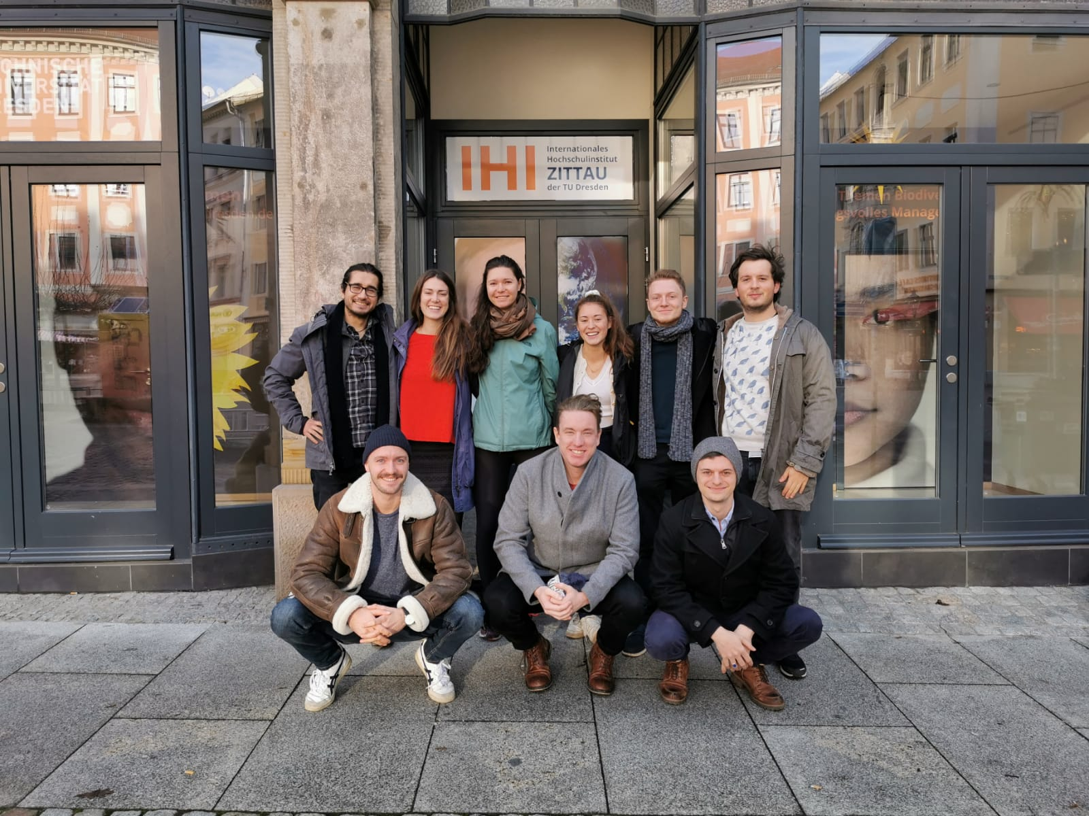

Important Contacts

Fachschaftsrat (FSR) – Student Representatives: we represent the local students’ interests.

FSR Office:
Room 0.02, Markt 23
02763 Zittau
E-Mail: fsr.ihi@mailbox.tu-dresden.de

Contact for problems in or relating the university:
Ms. Iris Merkelbach:
iris.merkelbach@mailbox.tu-dresden.de

Contact for international students:
Mr. Victor Jorquera:
victor.jorquera@mailbox.tu-dresden.de

Tutor – Contact person for foreign students:
Ms. Sarah Deutscher:
sarah.deutscher@mailbox.tu-dresden.de

Ms. Claudia Christensen Garcia:
claudia_maria.christensen_garcia@mailbox.tu-dresden.de
Assistance for problems and questions regarding student life at the IHI, in Zittau, in Germany as well as exam preparation or concerns about your study program.

Should you have any other question, please do not hesitate to contact or approach anyone of us in person, we are glad to help or direct you to where you can find further assistance!
Student sport:
http://www.hszg.de/campusleben/hochschulsport/angebot.html
Enrollment day: 04.10.2020
You can register to the sport classes with your IHI credentials. There are designed terminals in the Haus Z I, room 0.27 in Zittau and in the Haus GII, room 12 in Görlitz to pay for the chosen courses with your student card.
You can find all the related information on the website of the Hochschule Zittau/Görlitz (HSZG) under Hochschulsport (link)!

Important Corona-Hygiene Rules
The Covid-19-pandemic is still ongoing. It is therefore important to remain attentive to keep the risk of infection for you and others as low as possible!
Since the risk of infection is particularly high in closed rooms, during conversations and in large groups, you should continue to follow these rules:
- Keep your distance! (1.5 meters)
- Observe hygiene!
- Wear your mask!
- Ventilate!
You can find more detailed information about the distance & hygiene rules under the following link:
https://www.infektionsschutz.de/coronavirus/

Contact data: Health Department (Gesundheitsamt) Görlitz +49 3581 663-5656

Studentenwerk Dresden in Zittau or Görlitz – student halls and
accomodation/canteens
https://www.studentenwerk-dresden.de/english/wirueberuns/corona-informatione
n.html
Information by the TU-Dresden: www.tu-dresden.de/corona

Other
Emergency numbers:
- Police: 110
- Fire/Ambulance: 112

Telephone area codes:
- Zittau: 03583
- Görlitz: 03581
- Dresden: 0351
- Czech Republic: 00420
- Poland: 0048

Free time in Zittau
Zittau is located in a beautiful area which is rich in interesting cities, landscapes and nature. You should explore and enjoy it! Here are some examples:
- The Olbersdorfer lake
- The Zittauer mountains
- Liberec
- Prag
- Bautzen
- The Biosphere Reserve Oberlausitzer Heide- und Teichlandschaft (moorlands, bird reservoir)
- The Spreewald (forest)

Events
The student representatives of IHI as well as the Hochschule Zittau/Görlitz organise regularly events and parties. You will get information via E-Mail or at the IHI (FSR Info-board).

Important dates of the academic year 2020/21
Winter semester 2020/2021
- Official period: 01.10.2020 – 31.03.2021
- First Semester-Week: 19.10. – 23.10.2020
- Start of lectures: 26.10.2020
- Courses and lectures: 26.10. – 19.12.2020 and 04.01. – 06.02.2021
- Re-registration period for the summer semester 2020: 15.01. – 05.03.2021
- Main exam period: 08.02. – 06.03.2021
- Bank holidays:
  - Reformation day: 31.10.2020
  - Day of prayer and repetance: 18.11.2020
  - Turn of the year: 19.12.2020 - 04.01.2021

Lecture-free period: 06.02.2021 - 31.03.2021

Summer semester 2021
- Official period: 01.04.2021 – 30.09.2021
- Courses and lectures: 12.04. – 24.07.2021
- Main exam period: 02.08.2021 - 21.08.2021
- Bank holiday
  - Easter: 02.04.2021 - 05.04.2021
  - 1st May: 01.05.2021
  - Dies academicus: 05.05.2021
  - Ascension day: 13.05.2021
  - Pentecost: 21.05.2021

Lecture-free period: 25.07.2021 – 30.09.2021

Our university in Zittau
Student office:
Markt 23, Room 3.02 [Main university building]
O2763 Zittau
E-Mail: studium.ihi@tu-dresden.de
Telephone: +49 3583 61241-12/22
Opening hours:
Mon & Tue: 9:30 – 12:00
Wed & Thu: 13:00 – 15:00 (or by arrangement)

Ms. Dipl.-Verw. (FH) Uta Scheunig
E-Mail: uta.scheunig@tu-dresden.de; Room 3.05
Telephone: 03583 / 612-4115

Ms. Heike Effenberger
E-Mail heike.effenberger@tu-dresden.de; Room 3.02
Telephone: 03583 / 612-4122

Ms. Peggy Korschelt
E-Mail: peggy.korschelt@tu-dresden.de; Room 3.02
Telephone: 03583 / 612-4112

Our student office also serves as examination office and international office!
The student office deals with:
- Enrolment and re-Enrolment
- Exams (registration, optional modules)
- Erasmus and other international exchanges
- Recognition of credits and exams
- Recognition of internships

Free consultation and advice services for students
Legal Advice:
Zittau
Mon – Fri 09:30 – 16:00 Legal advice by e-mail or telephone
Hochwaldstraße 12, Zittau

Mr. Gert Sureck
E-Mail: studentische-rechtsberatung@studentenwerk-dresden.de
Telephone: 0049 351 / 4697-809

Mr. Thomas Neumann
E-Mail: info.zittau-goerlitz@studentenwerk-dresden.de
Telephone: 0049 3583 / 6881-55

Görlitz and Dresden
E-Mail: studentische-rechtsberatung@studentenwerk-dresden.de
Telephone: 0049 351 / 4697-809

Psychosocial Counselling:
Zittau
Every first Wednesday of the month
Hochwaldstraße 12, Room 0.2.13
Ms. Dipl.-Päd. Nancy Ludwig
E-Mail: nancy.ludwig@studentenwerk-dresden.de

Görlitz
Every first Thursday of the month
Vogtshof, House 4.1, 1st Floor
Gottfried-Kiesow-Platz 2, 02826 Görlitz
Ms. Dipl.-Päd. Nancy Ludwig
E-Mail: nancy.ludwig@studentenwerk-dresden.de
Social Counselling:
Telephone consultation Tue & Thu: 9-12 & 13-17
Brückenstraße 1, House II, Room 264
02826 Görlitz [On campus of the HSZG in Görlitz]

Contact and Appointments via:
E-Mail: sozialberatung@studentenwerk-dresden.de
Telephone: 0049 351 / 4697 - 661 or - 662

Opening a bank account
There are several possibilities in Zittau in order to open a bank account. Here are some examples:
Deutsche Bank
Neustadt 47, Zittau
Commerzbank
Neustadt 13-15, Zittau
Sparkasse
Frauenstraße 21, Zittau

There are many online banks as well, e.g.:
https://www.dkb.de/
If you do not speak German, we are happy to help you with the appointment at the bank! Just contact us or the Tutor.

Important: Re-registration!
To continue your studies after the first semester, it is necessary to transfer the semester fees (with or without the semester ticket) within the re-registration period for the next semester. The student office will inform you further before the due time.
Re-registration for the summer semester 2021: 15.01. – 05.03.2021

Online services
Student Portal:
Here you can find your enrollment certificates, the overview of your grades, information regarding the re-registration and so on.
https://studenten.ihi-zittau.de/qisserver/rds?state=user&type=0&category=menu.browse&breadCrumbSource=portal&startpage=portal.vm

Opal:
Here you can find the learning materials and other important information regarding your modules. The portal serves as forum for the students too, to exchange advice and opinions on the contents of the courses. Your professors will provide you with the credentials to access each module during the lectures.
https://bildungsportal.sachsen.de/opal/shiblogin

Library
Hochwaldstraße 12, 02763 Zittau
Opening hours: Mon, Wed, Thu, Fri: 10 - 15; Tue: 10 - 18
(changing opening hours during the summer and the exam period check the website)

Website: http://hsb.hszg.de/

The library has several facilities, such as copy rooms, scanners, PC-Pools, seminar rooms and private study rooms.

Cafeteria
Hochwaldstraße 12, 02763 Zittau (under the library)
In the cafeteria you can also find:
- Terminals to load money on your student card. With your student card you can pay the food in the canteen or the fees for the sport classes, as well as copies in the library.
- A board with lot of interesting information such as job offers or other events in Zittau and the surrounding area.

Other services at the IHI
PC-Labs
Markt 23, 2nd floor, Room 2.02 (Lehrkabinett)
Markt 21, ground floor, Room 0.52 (on the left side of the corridor after the big stairs)
Access only with the student card! You are free to use the computers, the scanner and the printers. In order to print you do not have to pay but you need to bring your own printing paper!

Info-screen
It is located directly at the main entrance of the building at Markt 23. It provides information about lectures schedules, changes of rooms and events.

Info-boards and foyer
1st and 2nd floor, Markt 23. Information for all programmes, events.
- In the Foyer in front of the student office you can find more informative materials from the TU Dresden and other partners.

Info-board oft the student representatives (FSR)
1st floor, Markt 23 Here you can find all the information regarding the activities and events organized by the student council. You should always have a look there

Facility Management Dormitories D, E, F
Mr. Jens Hebestreit
E-Mail: jens.hebestreit@studentenwerk-dresden.de
Telephone: 0049 3583 / 688121
Mobile: 0049 162 2946101
Opening Hours:
Mon: 7:30 – 7:45 and 11:45 – 12:15 and 15 – 15:30
Tue and Fri: 7:30 – 7:45 and 11:45 – 12:15
Thu: 7:30 – 7:45 and 11:45 – 12:15 and 15 – 17

Facility Management Dormitories G
Lutherplatz 4, Lindenstraße 30 und 18
Mr. Mario Herrmann
E-Mail: mario.herrmann@studentenwerk-dresden.de
Telephone: 0049 162 2946102,
Opening Hours:
Mon: 7:30 – 7:45 and 11:45 – 12:15 and 15 – 15:30
Tue and Fri: 7:30 – 7:45 and 11:45 – 12:15
Thu: 7:30 – 7:45 and 11:45 – 12:15 and 15 – 17

In case of emergency: technical Facility Management during duty hours
Telephone: 0049 3583 / 688143
Mobile: 0049 162 2946100

Important:
As soon as you receive your residence permit or an extension of you visa, you have to report it to the student office!

IMPORTANT!!! Please always carry your residence permit, the residence form as well as an identification document with you!!! The state police can perform random controls/searches!!!

Finding a room/apartment in Zittau
Popular websites:
https://www.wg-gesucht.de/
http://www.wohnheim-zittau.de/

Student dormitories
Administration: Studentenwerk Dresden
http://www.studentenwerk-dresden.de/goerzitt/
Hochwaldstraße 12, 02763 Zittau [next to the canteen]
Opening Hours:
Tue: 9 – 12:30 Wed: 11 – 12:30 Thu: 13 – 17

Mr. Ralph Böhm
E-Mail: ralph.boehm@studentenwerk-dresden.de
Telephone: 0049 3583 / 688 158

Ms. Heidemarie Michel
E-Mail: heidemarie.michel@studentenwerk-dresden.de
Telephone: 0049 3581 / 406388

Getting Started in Germany
Mandatory health insurance
Without health insurance you are not allowed to enroll at the univeristy.
Documents to bring with you for the registration at the health insurance: passport photo, enrolment certificate, rental contract and visa certificates.
There are several health insurance companies in Germany which you can choose from. We gathered some examples for you:

Techniker Krankenkasse
Local contact: Mr. Jörg Militzer
Telephone: 0049 – 4773897
Mobile: 0049 151 44682366
E-Mail: joerg.militzer@tk.de

Barmer
Local contact: Mr. Philipp Schöbel
Telephone: 0049 800 – 333004106489
Mobile: 0049 151 18234102
E-Mail: philipp.schoebel@barmer.de

AOK Plus
Local contact: Herr Silvio Hornig
Telephone: 0049 800 - 1059037186
Mobile: 0049 152 01570833
E-Mail: silvio.hornig@plus.aok.de

Important: Upon arrival, you should find a GP (general practitioner)! This ensures a fast admission in case of an emergency.

For international students: It might be useful during the first visit to the chosen GP to be accompanied by a German-speaking person (e.g. Tutor).

There are also multiple practitioners in Zittau, who are worth considering:

Ms. Eder M.D.
Telephone: 03583 / 791970
Lessingstr. 33
02763 Zittau

Ms. Krause M.D.
Telephone: 0049 3583 512227
Schrammstr. 29
02763 Zittau

Registration Office:
Important: you should register within the first two weeks after moving to Zittau!

Where to go: The municipal administration for passports and registration
Bürgeramt – Referat Pass- und Meldewesen
Franz-Könitzer-Str. 7, Room 216
02763 Zittau [Next to the local fire department]
Telephone: 0049 3583 / 752450
Opening Hours:
Mon, Wed and Fri: 9 – 12
Tue: 9 – 12 and 13:30 – 18
Thu: 9 – 12 and 13:30 – 15
Documents to bring: passport/ID, rental contract and visa certificate.

Only for Non-EU Nationals:
Registration at the foreign citizens’ office application for a residence permit
Documents to bring with you (Original + Copy): passport/ID, rental contract, proof about your protection of subsistence, proof about DSH-course, proof of health insurance, registration certificate (registration office), application form for the residence permit and visa certificate.

Important: apply for your residence permit IMMEDIATLY!

If you do not, you need to re-apply for another Visa with foreigner's registration office 10 weeks before the previous Visa expires.

Foreign registration office for the district of Görlitz
Landratsamt Görlitz, Außenstelle Zittau
Hochwaldstraße 29
02763 Zittau
E-Mail: info@kreis-gr.de
Telephone: 0049 3581 / 663-5190
Opening Hours:
Tue, Thu: 8:30 – 12 and 13:30 – 18
Fri: 8:30 – 12

Contact for Zittau: Mrs. Richter
Telephone: 03581 / 663 5162
E-Mail: bettina.gringmuth@kreis-gr.de
Müller-Straße 7

