
International Office // Strategie und Internationalisierung
Bereich Internationalization@Home

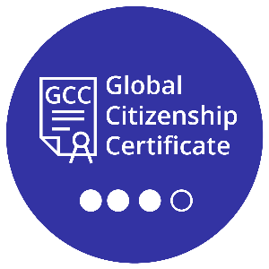
TUD Global Citizenship Certificate
Reflection report upon program completion

Last name, first name:
Degree program, semester of study:
Enrollment number:
Email address:
Time period of program participation:
Date of submission:
Contents
TUD Global Citizenship Certificate Reflection report upon program completion 1
Activities completed for knowledge and skills aquisition as part of GCC 2
Reflecting on your own experiences with GCC 2
Outlook and Feedback 3

Activities completed for knowledge and skills acquisition as part of GCC

Reflecting on your own experiences with GCC

Outlook and Feedback

