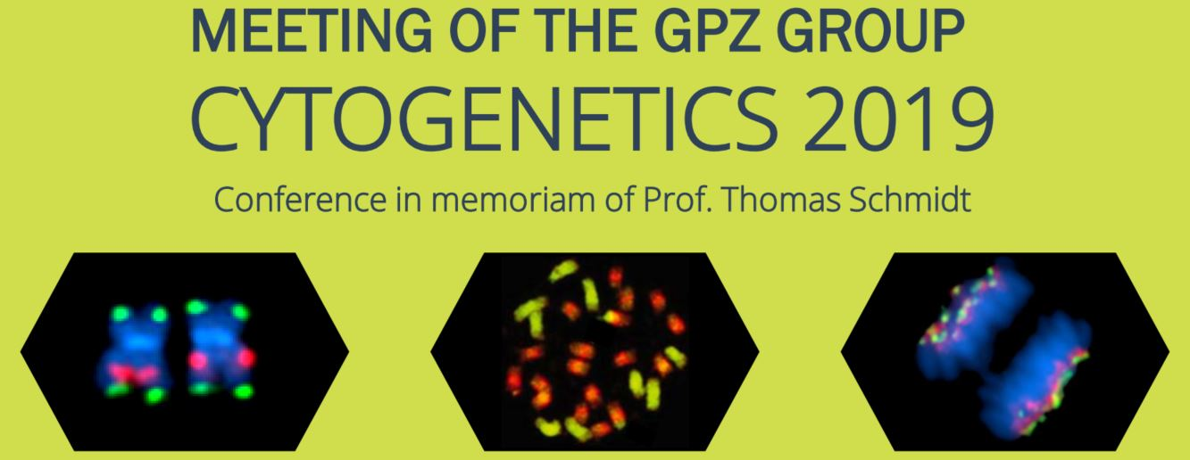

ABSTRACT SUBMISSION FORM
Please send to tony.heitkam@tu-dresden.de (CC: houben@ipk-gatersleben.de)

Type of presentation
talk poster as the organizers see fit

Title

Author details
Presenting author:
Complete author list:

Institutions of the authors (please mark with ¹,²,³,…):

Abstract
Please paste your abstract here (250 words maximum):

