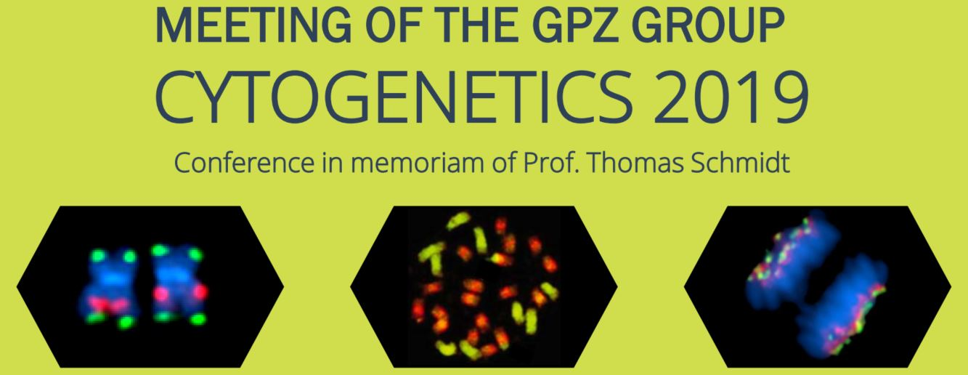

REGISTRATION FORM
Please send to tony.heitkam@tu-dresden.de (CC: houben@ipk-gatersleben.de)

Registration Details

Mr. Ms. Dr. Prof.
Family Name: First Name:
Institution: Department:
Address:
Zip code: Town: Country:
Phone: Email:
Specific diet requirements (vegetarian, allergies …): …………………………....................................................................

Registration Fee
For participation, all attendees have to pay an attendance fee of € 100. On-site registration and payment is not possible. Please transfer your payment to the following bank account:
Account holder: Leibniz-Institut für Pflanzengenetik und Kulturpflanzenforschung (IPK)
Bank name: Salzlandsparkasse
IBAN: DE76 8005 5500 3062 0013 63
BIC/SWIFT: NOLADE21SES
Communication: Delegate’s name/0009213

